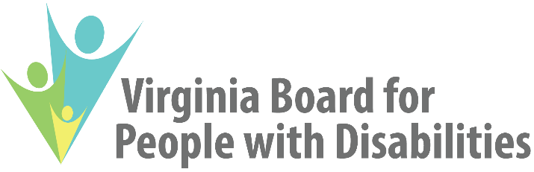

2024 Update to the Five-Year State Plan
Goals, Objectives, and Activities
In Plain Language

Visit this website for more information.
Please email this email address if you need this document in a different format. You can also call 804-786-0016 or 1-800-846-4464 for voice/TTY. You can also send mail to 1100 Bank Street, 7th Floor, Richmond, Virginia, 23219.

Who is the Virginia Board for People with Disabilities?
Each state has a Council to help meet the needs of people with developmental disabilities. In Virginia, this Council is called the Virginia Board for People with Disabilities. This Council is also referred to as “the Board.”
The Board’s mission has three main parts. First, the Board wants people with disabilities to be independent. Second, the Board wants them to make their own decisions. Third, the Board wants them to be full participants in their communities.
The Board works toward this mission in three main ways. First, the Board advocates for changes to policy. Second, the Board funds grant projects. Third, the Board trains people with disabilities and their families on advocacy.

What is a State Plan?
The Board has to create a State Plan every five years. The State Plan identifies how the Board will work towards its mission. The current State Plan is for October 1, 2021 through September 30, 2026.
The Board created the State Plan based on data and input from the public and Board members. The Board also made sure that the State Plan is feasible and flexible.
The State Plan has three levels of information. First, the State Plan has goals. Second, the State Plan has objectives to work towards each goal. Third, the State Plan has activities to work towards each objective.

What is a State Plan Update?
The Board has to update the State Plan every year. The 2024 Update is the second update to the current State Plan. The Board submitted the update on August 10, 2023.

What is in the Board’s Current State Plan?
The Board’s State Plan is summarized in the following pages. No substantive changes were made to the State Plan for 2023. The Board aims to respect different cultures and languages in all its work.

Goal 1: Community Supports
The first goal is for people with disabilities to have better access to supports so they can live in the community.
The first objective for this goal is to increase access to information on supports.
The Board has four activities for the first objective. First, the Board will advocate for changes to policies and practices in the first three years of the State Plan. Second, the Board will also update information on its website each year. Third, the Board will map the study and recommend changes to how information on Virginia’s Medicaid services is shared in the second and third years of the State Plan. Fourth, the Board will share information with people who do not speak English in the last three years of the State Plan.
The second objective for this goal is to increase access to supports in rural areas.
The Board has four activities for the second objective. First, the Board will study and recommend changes to policies and practices in the second and third years of the State Plan. Second, the Board will fund a project to implement one or more of the recommended changes in the last two years of the State Plan. Third, the Board will support a grant project to increase access to assistive technology in the first four years of the State Plan. Fourth, the Board will support a grant project to match people with brain injuries to adults in their community in the first three years of the State Plan.
The third objective for this goal is to reduce barriers to living in the community.
The Board has four activities for the third objective. First, the Board will recommend changes to policies and practices each year. Second, the Board studied and recommended changes to consumer-directed services in the first two years of the State Plan. Third, the Board will support a grant project to train service providers for people who are deafblind in the last four years of the State Plan. Fourth, the Board will support a grant project to train service providers on equity and inclusion in the first four years of the State Plan.
The fourth objective for this goal is to increase public awareness about people with disabilities.
The Board has two activities for the fourth objective. First, the Board will support a public awareness campaign in the last four years of the State Plan. Second, the Board will educate the news media in the last year of the State Plan.
The fifth objective for this goal is to address new problems when they emerge.

Goal 2: Health and Safety
The second goal is for people with disabilities to have better access to services so they can be healthy and safe.
The first objective for this goal is to increase access to healthcare services.
The Board has three activities for the first objective. First, the Board will recommend changes to policies and practices each year. Second, the Board will support a grant project to educate wellness instructors on inclusion in the first four years of the State Plan. Third, the Board will help dental providers be more accessible in the third and fourth years of the State Plan.
The second objective for this goal is partner with others to reduce barriers to healthcare.
The Board has two activities for the second objective. First, the Board will study and recommend changes to improve the accessibility of healthcare providers in the second and third years of the State Plan. Second, the Board will educate people with disabilities and their caregivers on oral health in the last three years of the State Plan.

The third objective for this goal is to increase the ability to be free from abuse, neglect, and exploitation.
The Board has three activities for the third objective. First, the Board will recommend changes to policies and practices each year. Second, the Board finished participating in Project Living Well in the first year of the State Plan. Third, the Board will monitor care in institutions each year. Fourth, the Board will recommend changes to emergency management policies and practices in the last three years of the State Plan.
The fourth objective for this goal is to address new problems when they emerge.

Goal 3: Education and Employment
The third goal is for schools and employers to better include people with disabilities.
The first objective for this goal is to promote inclusion in schools.
The Board has four activities for the first objective. First, the Board will recommend changes to policies and practices each year. Second, the Board will study and recommend changes to the impact of COVID-19 on learning in the last two years of the State Plan. Third, the Board will support a grant project to train parents about their children’s educational rights during the last three years of the State Plan. Fourth, the Board will support a grant project to train school personnel on inclusion in the final year.
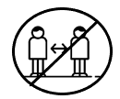
The second objective for this goal is to reduce the seclusion of diverse students from school.
The Board has one activity for the second objective. The Board studied and recommended changes to policies and practices in the first two years of the State Plan.
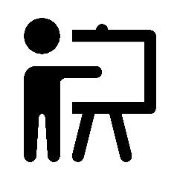
The third objective for this goal is to train key stakeholders on integrated employment with competitive pay.
The Board has three activities for the third objective. First, the Board shared information on employment in the second year of the State Plan. Second, the Board will support a grant project to train people with disabilities, their family members, or employers on employment in the final year of the State Plan.
The fourth objective for this goal is to reduce barriers to integrated employment with competitive pay.
The Board has three activities for the fourth objective. First, the Board will recommend changes to policies and practices each year. Second, the Board will study and recommend changes to employment policies in the last two years of the State Plan. Third, the Board will study and recommend changes to transition services in the last two years of the State Plan.

Goal 4: Self-Advocacy
The fourth goal is for people with disabilities and their families to be better able to advocate for themselves and others.
The first objective for this goal is to create or strengthen an advocacy organization that is led by people with developmental disabilities.
The Board has two activities for the first objective. First, the Board will support a grant project to strengthen the ALLY Alliance in the first four years of the State Plan. Second, the Board will support one or more additional projects to create or strengthen an advocacy organization in the last three years of the State Plan.
The second objective for this goal is for 15 or more people with disabilities to train other people with disabilities.
The Board has two activities for the second objective. First, the Board will train people with disabilities on how to be trainers in the first, third, and fifth years. Second, the Board will use people with disabilities as trainers each year.

The third objective for this goal is for 50 or more people with developmental disabilities to advocate for policy changes.
The Board has three activities for the third objective. First, the Board will hold a Youth Leadership Academy in the second and fourth years of the State Plan. Second, the Board will hold a Partners in Policymaking program in the first, third, and fifth years of the State Plan. Third, the Board will have an Alumni Development Program to provide continuing education for disability stakeholders.
The fourth objective is for 100 or more family members of people with developmental disabilities to advocate for policy changes.
The Board has two activities for the fourth objective. First, the Board will hold a Partners in Policymaking program in the first, third, and fifth years of the State Plan. Second, the Board will have an Alumni Development Program to provide continuing education for disability stakeholders.

