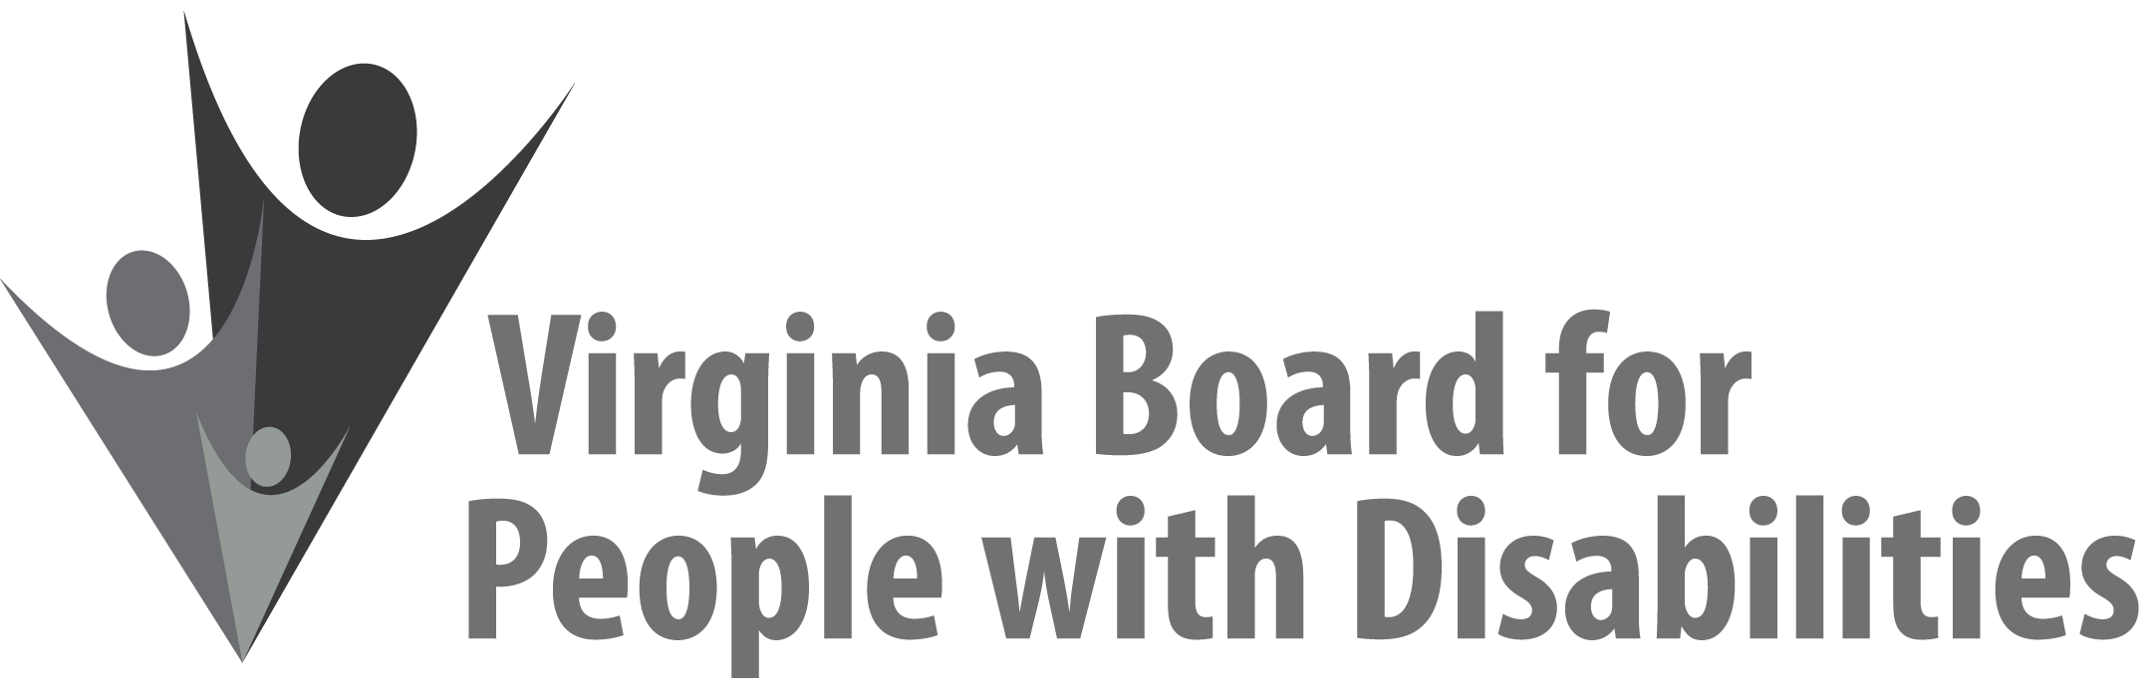

Mission
To create a Commonwealth that advances opportunities for independence, personal decision-making and full participation in community life for individuals with developmental and other disabilities.
Vision
Virginians with developmental and other disabilities direct their own lives and
choose how they live, learn, work, and play.
BOARD MEETING AGENDA

March 8, 2022 - Zoom Meeting

9:00am - 9:20am Executive Committee (Attachment EC 1)

9:20am-9:30am Break

9:30-10:00am COMMITTEE MEETINGS
Advocacy, Outreach, and Training – Zoom
Investment Committee – Zoom
Policy Advisory Committee – Zoom

10:10 FULL BOARD CONVENES
Welcome & Introductions – Alexus Smith
Review Agenda
December 9, 2021 Board meeting minutes, No ACTION REQUIRED (Attachment BD 1), Alexus Smith
10:25 Public Comment
10:30 Appointment of Nominations Committee, Alexus Smith
10:40 DSAGR event update
10:50 Legislative Update, Clare Huerta
11:00 Standing Committee Reports and Discussion:
Advocacy, Outreach, and Training – Eric Mann
Investment Committee – Chandra Robinson
Policy Advisory Committee – Clare Huerta

11:20 – 11:30 Break

11:30 Cultural & Linguistic Competence, Dr. Vivian Jackson and Marisa Brown

12:15 Lunch

12:45 Cultural & Linguistic Competence, Dr. Vivian Jackson and Marisa Brown

2:45 Other Business & Discussion

3:00 FULL BOARD ADJOURNS

