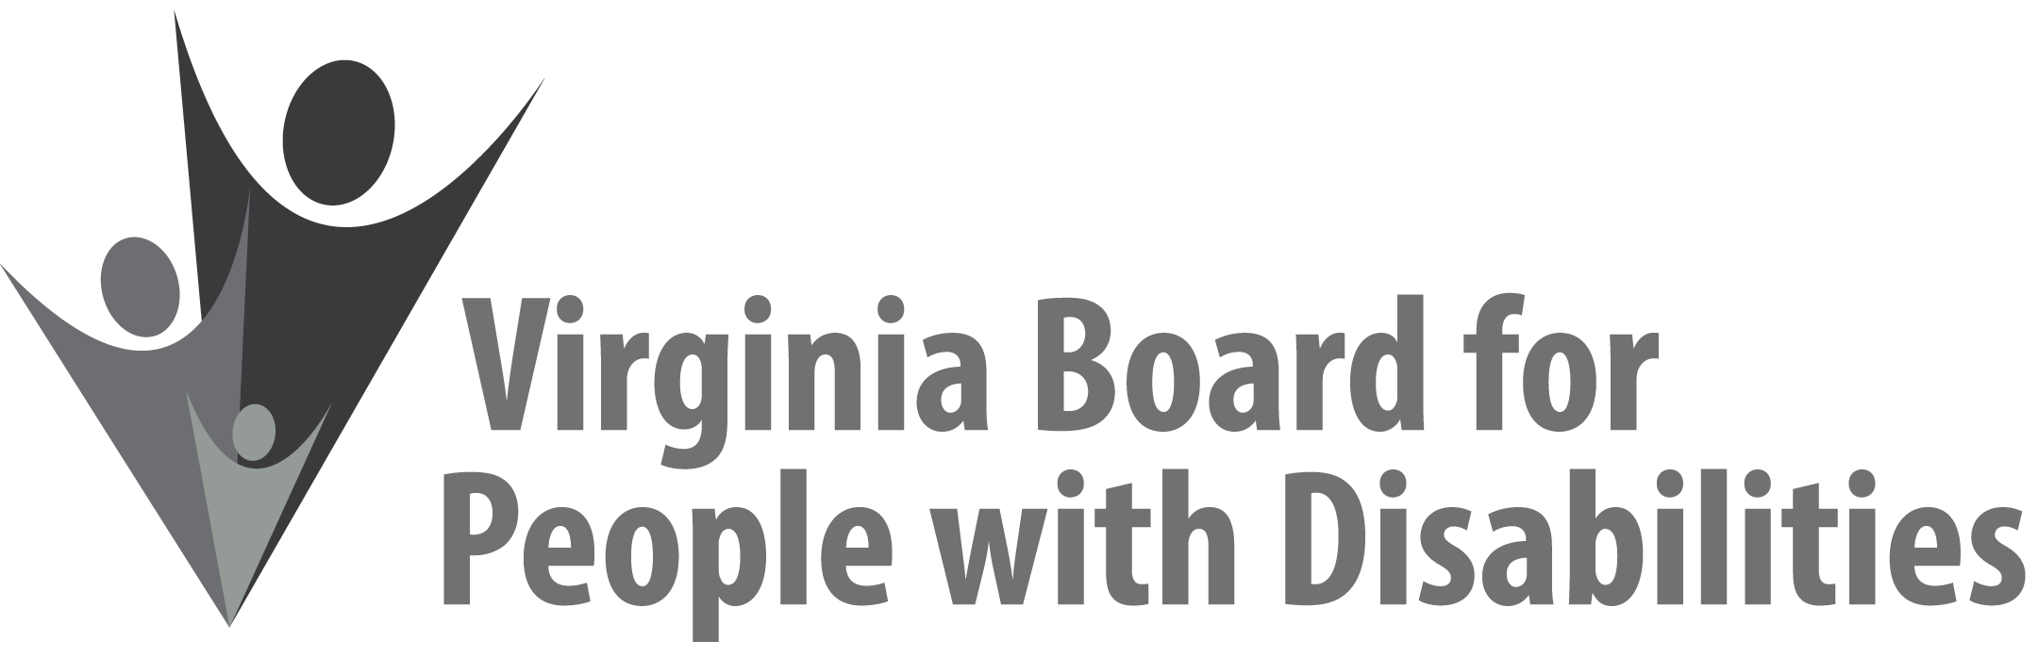

Mission
To create a Commonwealth that advances opportunities for independence, personal
decision-making and full participation in community life for individuals
with developmental and other disabilities.

Vision
Virginians with developmental and other disabilities direct their own lives
and choose how they live, learn, work, and play.

EXECUTIVE COMMITTEE AGENDA

December 8, 2021 – Blue Ridge Ballroom

8:00 Call to Order and welcome, Alexus Smith
8:03 Review of Executive Committee Meeting Agenda (Attachment EC 1),
Alexus Smith
8:05 Approval of September 15, 2021 Executive Committee Minutes
ACTION REQUIRED (Attachment EC 2), Alexus Smith
8:10 Board Member Attendance (Attachment EC 3), Sarah Kranz-Ciment
8:15 Questions on Executive Director’s Update (Attachment EC 4), Teri Morgan
8:20 Questions on Agency Fiscal Reports (Attachment EC 5), Henry Street
8:25 Approval of revised SFY 2022 Board Operational Budget, ACTION
REQUIRED (Supplemental Packet)
8:40 Committee agendas, Committee Chairs/Staff
8: 45 Other business & Adjourn

