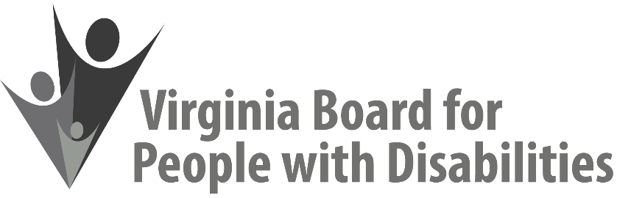
Mission
To create a Commonwealth that advances opportunities for independence, personal decision-making and full participation in community life for individuals with developmental and other disabilities.

Vision
Virginians with developmental and other disabilities direct their own lives and choose how they live, learn, work, and play.

COMMITTEE AGENDAS, March 8, 2022 (via Zoom)
CLICK HERE TO JOIN COMMITTEE MEETING

Investment Committee Agenda
9:30 a.m. | Call to Order and Review of Agenda (Attachment IC 1) | Chandra Robinson, Chair
9:35 a.m. | Review of December Minutes (Attachment IC 2)  No ACTION REQUIRED | Chandra Robinson, Chair
9: 40 a.m. | Grants and Contracts - Updates and Discussion  - Expenditures Report (Attachment IC 3)  - Update on ECNV grant project (Attachment IC 4)  - Update on VDDHH grant | Jason Withers
9:55 a.m. | Wrap Up and Potential Future Meeting Topics | Chandra Robinson, Chair
10:00 a.m. | Adjourn

