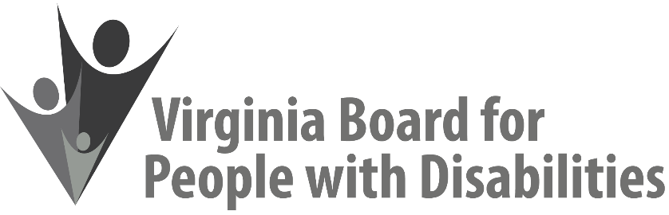
Mission
To create a Commonwealth that advances opportunities for independence, personal decision-making and full participation in community life for individuals with developmental and other disabilities.

Vision
Virginians with developmental and other disabilities direct their own lives and choose how they live, learn, work, and play.

BOARD MEETING AGENDA, March 8, 2022 (via Zoom)
CLICK HERE TO JOIN FULL BOARD MEETING
10: 10 a.m. | FULL BOARD CONVENES  Welcome & Introductions  Review Agenda  December 9, 2021 Board meeting minutes  No ACTION REQUIRED (Attachment BD 1) | Alexandra Dixon
10:25 a.m. | Public Comment
10:30 a.m. | Appointment of Nominations Committee | Alexandra Dixon
10:40 a.m. | DSAGR event update
10:50 a.m. | Legislative Update | Clare Huerta
11:00 a.m. | Standing Committee Reports and Discussion:  Advocacy, Outreach, and Training  Investment Committee  Policy Advisory Committee | Eric Mann  Chandra Robinson  Phil Caldwell
11:20 – 11:30 a.m. | Break
11:30 a.m. | Cultural & Linguistic Competence | Dr. Vivian Jackson and Marisa Brown
12:15 p.m. | Lunch
12:45 p.m. | Cultural & Linguistic Competence | Dr. Vivian Jackson and Marisa Brown
2:45 p.m. | Questions Regarding Agency Updates & Other Business | Alexandra Dixon
3:00 p.m. | FULL BOARD ADJOURNS

