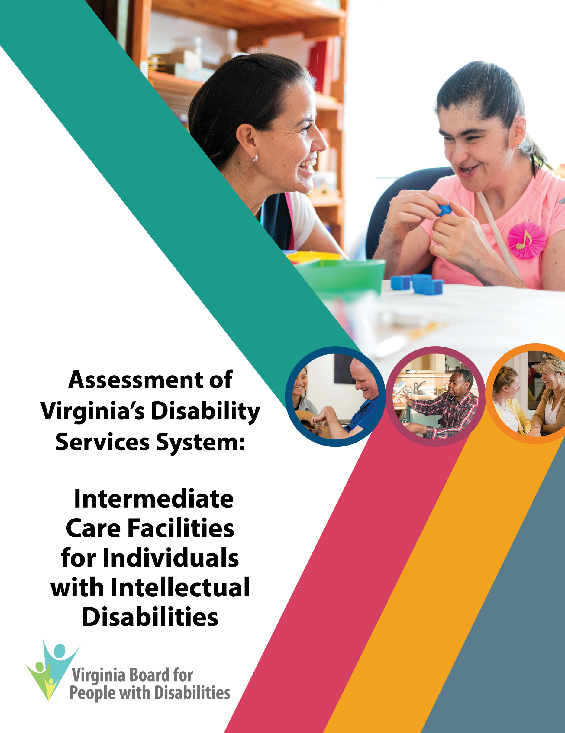

2021 Assessment of Intermediate Care Facilities
for Individuals with Intellectual Disabilities

First edition

This report is also available in alternative formats by request and on the Virginia Board's website. For more information, please contact the Board at:

Virginia Board for People with Disabilities
Washington Office Building
1100 Bank Street, 7th Floor
Richmond, VA 23219

804-786-0016
804-846-4464 (Toll-free)
804-786-1118 (Fax)
e-mail: info@vbpd.virginia.gov
www.vaboard.org

Funding for this product was supported, in part, by the Virginia Board for People with Disabilities, under grant number 2001VASCDD01, from the U.S. Administration for Community Living (ACL), Department of Health and Human Services, Washington D.C., 20201. Grantees undertaking projects with government sponsorship are encouraged to express freely their findings and conclusions. Points of view or opinions do not, therefore, necessarily represent official ACL policy.

The Virginia Board for People with Disabilities would like to
thank all of the agencies, organizations, and other individuals
who contributed data and information to this Assessment.

VBPD Chair
Matthew Shapiro

VBPD Executive Director
Teri Morgan

Author
Nia Harrison, Director of Planning, Research, & Evaluation

Editing
Benjamin Jarvela, Director of Communications
Megan Weems, Communications Assistant

Special thanks to the members of the Virginia Board
for People with Disabilities Disability Assessment subcommittee

Alexus Smith • Donna Lockwood • Phil Caldwell
Ed Turner • Frederique Vincent

June 30, 2021

The Virginians with Disabilities Act § 51.5-33 directs the Virginia Board for People with Disabilities (VBPD), beginning July 1, 2017, to submit an annual report to the Governor, through the Secretary of Health and Human Resources, that provides an in-depth assessment of at least two major service areas for people with disabilities in the Commonwealth. In September 2020, the Board selected Intermediate Care Facilities for Individuals with Intellectual Disability (ICF/IID) as one of the areas to be covered in the 2021 Assessments. The Board, as part of its authority and responsibility as a Developmental Disabilities (DD) Council under the federal Developmental Disabilities and Bill of Rights Act (42 U.S.C.§15021-15029), is also required to complete a similar analysis as it develops and amends its federal State Plan goals and objectives.

In this Assessment, the Board seeks to identify critical issues, data trends, monitoring and oversight activities, and the coordination of those activities among responsible entities. In addition, the Board offers recommendations for improving the delivery and oversight of services for people with developmental disabilities residing in an ICF/IID in the Commonwealth.

The data for this Assessment was obtained from a variety of sources, including state and federal agency websites and reports, legislative studies, and various research publications. We appreciate the assistance of the state agencies that provided information and clarification on the services and oversight responsibilities relevant to their agencies. The policy recommendations contained within this Assessment were developed by an ad hoc committee of the Board and approved by the full Board at its June 9, 2021 meeting.

Statement of Values | i
Executive Summary | ii
Background | 1
I. Minimizing Utilization of ICF/IIDs | 2
Number of ICF/IIDs and Residents Over Time | 2
State Oversight of ICF/IID Development | 4
State Oversight of ICF/IID Admissions and Discharges | 6
RECOMMENDATIONS RELATED TO MINIMIZING UTILIZATION OF ICF/IIDS | 10
II. Minimizing ICF/IID Costs | 12
Medicaid Reimbursement Rates to ICF/IIDs | 12
Medicaid Reimbursement Rate Methodology | 14
RECOMMENDATIONS RELATED TO REDUCING ICF/IID COSTS | 16
III. Ensuring Health and Safety in ICF/IIDs | 17
Medicaid Certification of ICF/IIDs | 17
State Licensure of ICF/IIDs | 25
RECOMMENDATIONS RELATED TO ENSURING HEALTH AND SAFETY IN ICF/IIDS | 30
IV. Improving Coordination of ICF/IID Oversight | 33
Fragmented Oversight of ICF/IID Utilization | 33
Fragmented Oversight of ICF/IID Payment | 34
Fragmented Oversight of ICF/IID Quality of Care | 34
RECOMMENDATIONS RELATED TO IMPROVING COORDINATION OF ICF/IID OVERSIGHT | 35
Appendix A: Certificate of Public Need Criteria for ICF/IIDs | 36
Appendix B: Medicaid Conditions of Participation & Key Standards for ICF/IIDs | 39
Appendix C: Rights of Individuals Receiving Services by Licensed Providers | 42
Works Cited | 44

Table of Contents

Statement of Values

"Physical or mental disabilities in no way diminish a person’s right to fully participate
in all aspects of society, yet many people with physical or mental disabilities have been precluded from doing so because of discrimination …; historically, society has tended to isolate and segregate individuals with disabilities, and, despite some improvements, such forms
of discrimination against individuals with disabilities continue
to be a serious and pervasive social problem ..."

— 42 U.S. Code § 12101 – Americans with Disabilities Act – Findings and Purpose

The Virginia Board for People with Disabilities serves as Virginia’s Developmental Disability Council. In this capacity, the Board advises the Governor, the Secretary of Health and Human Resources, federal and state legislators, and other constituent groups on issues important to people with disabilities in the Commonwealth. The following assessment of intermediate care facilities for individuals with intellectual disabilities is intended to serve as a guide for policymakers who are interested in ensuring that people with disabilities can live in the most integrated setting, consistent with their choice, and receive a high quality of care in whatever setting they choose. The Board’s work in this area is driven by its vision, values, and the following core beliefs and principles:

Inherent Dignity: All people possess inherent dignity, regardless of gender, race, religion, national origin, sexual orientation, or disability status.

Presumed Capacity: All people should be presumed capable of obtaining a level of independence and making informed decisions about their lives.

Self-determination: People with disabilities and their families are experts in their own needs and desires. They must be included in the decision-making processes that affect their lives.

Integration: People with disabilities have a civil right to receive services and supports in the most integrated setting appropriate to their needs and desires, consistent with the Supreme Court’s Olmstead decision.

Diversity: Diversity is a core value. All people, including people with disabilities, should be valued for contributing to the diversity of our neighborhoods and of the Commonwealth.

Freedom from Abuse and Neglect: People with disabilities must be protected from abuse, neglect, and exploitation in all settings where services and supports are provided.

Fiscal Responsibility: Fiscally responsible policies are beneficial for the Commonwealth, and they are beneficial for people with disabilities.

Executive Summary

While Virginia is focused on transitioning people with disabilities from institutions to home- and community-based settings, the Commonwealth should also focus on ensuring the well-being of those who remain in institutions. Virginia has closed four of five intermediate care facilities for individuals with intellectual disabilities (ICF/IIDs) that are operated by the Commonwealth, known as Training Centers, but the vast majority of ICF/IIDs are not operated by Virginia and will remain open. The utilization and cost of these other ICF/IIDs have increased in recent years, and there have been minimal consequences to providing substandard care (see Table 1).

Key Performance Indicator | Latest Data | Year | Trend
Utilization of ICF/IIDs
Number of ICF/IIDs | 62* | 2020 | ↑
Training Centers | 1* | 2021 | ↓
Other ICF/IIDs | 61* | 2020 | ↑
Number of ICF/IID Residents | 606* | 2020 | ↓
Training Centers | 98* | 2020 | ↓
Other ICF/IIDs | 508* | 2020 | ↑
Average Medicaid Expenditures Per Person Per Year
Training Centers | $398,587 | 2018 | ↑
Other ICF/IIDs | $230,943 | 2018 | ↑
Medicaid services for former Training Center Residents | $154,339 | 2017 | N.A.
ICF/IID Quality of Care
Substantiated allegations of abuse and neglect per 100 residents | 6.0 | 2020 | ↓
Training Centers | 4.1 | 2020 | ↓
Other ICF/IIDs | 6.3 | 2020 | ↓
Percent of ICF/IIDs with recurring certification deficiencies | 24% | 2018 | N.A.
Percent of ICF/IID certifications that are overdue | 32% | June 2019 | N.A.
Number of ICF/IID certifications terminated | 0 | 2020 | ↔
Number of ICF/IIDs with provisional licenses | 0 | March 2021 | N.A.
Table 1: Key Indicators of ICF/IID Utilization, Costs, and Quality of Care in Virginia.
* This data is from the CMS QCOR database. It is collected at the time of each facility’s annual certification survey, and therefore does not represent a single point in time across facilities.
Note: N.A. means the data was not available.

Virginia has improved its oversight of ICF/IIDs in recent years, but more work remains. The Virginia Department of Behavioral Health and Developmental Services (DBHDS) has reduced inappropriate admissions, increased opportunities to discharge children, and improved enforcement of state licensing laws. These efforts are commendable. However, the Commonwealth continues to rely too heavily on ICF/IIDs to regulate themselves, which poses a conflict of interest that jeopardizes the well-being of the people who live there.

Virginia has no restrictions on the development of smaller ICF/IIDs, despite its focus on transitioning people from institutions to less integrated settings. In recent years, Virginia actively solicited new ICF/IIDs in order to quickly accommodate people leaving Training Centers. This need should lessen in the coming years, however, now that the closure of Training Centers is complete and home- and community-based alternatives continue to be expanded. The Commonwealth should reevaluate its approach to regulating ICF/IID development accordingly.

Virginia has not adequately ensured that adults who remain in ICF/IIDs continue to need and want ICF/IID services. DBHDS recently improved its discharge processes for the two non-state-operated ICF/IIDs that serve children. However, the vast majority of Virginia’s ICF/IIDs serve adults. These facilities, in most cases, appear to be solely responsible for ensuring that their adult residents still need and want ICF/IID services. This approach poses a conflict of interest that could jeopardize people’s right to make an informed choice. Consequently, there may be people remaining in institutions who want to be served in the community.

Virginia has focused on avoiding institutional costs by transitioning people to home- and community-based settings, but has overlooked the cost of caring for people who remain in ICF/IIDs. Medicaid reimbursement rates have varied widely across ICF/IIDs and have increased over time. Reimbursement rates for non-state-operated ICF/IIDs are subject to a ceiling, but the ceiling may be artificially high. Unlike most other states, Virginia’s reimbursement methodology appears to lack incentives for providers to be cost efficient. Each dollar that supports inefficient ICF/IID operations could be redirected to home- and community-based services.

Virginia has not adequately enforced laws that govern ICF/IID quality of care. The Virginia Department of Health (VDH) is responsible for annually certifying that the facilities meet federal conditions for Medicaid participation. However, VDH has not completed these certifications on time, has identified violations at a much lower rate than other states, has not adequately verified that corrective actions were implemented, and has not used additional enforcement tools that are available beyond Plans of Correction. DBHDS is responsible for ensuring that facilities comply with state licensing and human rights laws. Nevertheless, DBHDS has not assessed the adequacy of services and supports, has relied heavily on providers to investigate critical incidents and has been reluctant to use enforcement tools beyond Corrective Action Plans.

Overall, the Commonwealth’s oversight of ICF/IIDs is fragmented across three state agencies. Both VDH and DBHDS oversee ICF/IID utilization, via a Certificate of Public Need process and limits on facility size, but their regulations do not align. Both VDH and DBHDS oversee the quality of care, via certification and licensure processes that operate independently of each other. The Department of Medical Assistance Services (DMAS) issues Medicaid payments to ICF/IIDs, which are supposed to be contingent on the provision of active treatment to eligible individuals, but it is not clear whether DMAS has taken action accordingly. This fragmentation likely limits Virginia’s ability to effectively oversee ICF/IIDs.

The Virginia Board for People with Disabilities offers 26 recommendations to improve the well-being of Virginians with disabilities who live in ICF/IIDs. The Board’s recommendations are listed below, grouped into four main goals.

Recommendations Related to Minimizing ICF/IID Utilization

- The Virginia General Assembly should amend the Section 32.1-102.1:3 of the Code of Virginia to require ICF/IIDs with more than six beds to obtain a Certificate of Public Need prior to development.

- The Virginia General Assembly should amend Section 37.2-315 of the Code of Virginia to specify that the Department of Behavioral Health and Developmental Services’ Comprehensive State Plan should address future demand versus supply for Medicaid residential services for people with disabilities, by type of service including ICF/IIDs. The analysis of future demand and supply should consider the barriers to serving people in home- and community-based settings, and the impact of feasible options for addressing those barriers.

- The State Health Services Plan Task Force should consult with the Department of Medical Assistance Services and the Department of Behavioral Health and Developmental Services when identifying recommended Certificate of Public Need criteria for ICF/IIDs in the revised State Health Services Plan.

- The State Health Services Plan Task Force should recommend the adoption of, and the Board of Health should adopt, the following Certificate of Public Need criteria for ICF/IIDs in the forthcoming State Health Services Plan for ICF/IIDs:
  - Criteria in the current State Medical Facilities Plan, per 12 VAC 5-230-870, amended per Recommendation 24 to reduce the bed limit from 20 to 12;
  - The ICF/IID is in an area that needs additional ICF/IID capacity, as identified by the Department of Behavioral Health and Developmental Services’ Comprehensive State Plan amended per Recommendation #2 to include ICF/IIDs;
  - The ICF/IID would be consistent with Virginia’s Settlement Agreement with the U.S. Department of Justice to serve individuals in the most integrated setting, consistent with individual choice; and
  - The ICF/IID’s operations will enable individuals to fully participate in their communities.

- The Department of Behavioral Health and Developmental Services should expand its annual Level of Care Reviews, which are currently conducted for children’s ICF/IIDs, to include all ICF/IIDs.

- The Department of Behavioral Health and Developmental Services should expand its annual training on alternative services in the community, which is currently offered to staff at children’s ICF/IIDs, to include all ICF/IIDs so they can adequately conduct their comprehensive assessments and reassessments required per 12 VAC 30-60-361.

- The Virginia General Assembly should provide any additional funding necessary for the Department of Behavioral Health and Developmental Services to expand its annual Level of Care Reviews (see Recommendation 5) and annual training on alternative community services (see Recommendation 6), from children’s ICF/IIDs to all ICF/IIDs.

- The Department of Behavioral Health and Developmental Services should expand its quarterly Regional Support Team report to include (i) Analysis of the barriers specific to individuals seeking admission to, or discharge from, ICF/IIDs; and (ii) Analysis of the barriers that were resolved, with respect to individuals seeking admission to or discharge from ICF/IIDs, including the percentage resolved by type of barrier and the resulting outcome. DBHDS should continue to make these reports available to the public on its website.

- The Virginia General Assembly should require the Virginia Department of Medical Assistance Services, in consultation with the Virginia Department of Behavioral Health and Developmental Services, to submit an annual report on the utilization of community ICF/IIDs that includes the following: (i) the number of ICF/IIDs, by size and ownership type, over time; (ii) the number of ICF/IID residents, by facility size and ownership type, over time; (iii) cost of ICF/IIDs to the state over time, by facility ownership type; (iv) barriers to serving ICF/IID residents in more integrated settings; and (iv) steps taken to address the barriers.

Recommendations Related to Minimizing ICF/IID Costs

- In keeping with the federal requirement that ICF/IID rates be established via a public process, the Department of Medical Assistance Services should add information about ICF/IID rates to their “Rate Setting Information” webpage and regularly update the information when changes occur. At a minimum, the information should include (i) a description of the ICF/IID rate methodology, (ii) rates for each ICF/IID, by facility size, for the most recent year, and (iii) the ceiling for non-state ICF/IID rates for the most recent year.

- The Virginia General Assembly should require the Department of Medical Assistance Services to study ICF/IID rates and report its findings to the General Assembly by November 1, 2022. The report should include (i) change over time in ICF/IID rates and possible explanatory factors, (ii) range of ICF/IID rates across facilities and possible explanatory factors, (iii) comparison of ICF/IID rates to the ceiling, as well as the appropriateness of the ceiling, (iv) incentives under the current reimbursement methodology regarding efficiency and effectiveness, (v) reimbursement rates in Virginia compared to other states, (vi) reimbursement methodologies used in other states, and (vii) recommendations for an alternative reimbursement methodology and its potential impact on cost and quality.

Recommendations Related to Ensuring Health and Safety in ICF/IIDs

- The Virginia Department of Health should ensure that certification and re-certification surveys for intermediate care facilities for individuals with intellectual disabilities are conducted within the federally required timeframes in 42 C.F.R. §442.109.

- The Virginia Department of Health should condition certain ICF/IID certifications on one of the following, as allowed per 42 CFR §442.110, with approval from the Centers for Medicare & Medicaid Services as needed: (i) all deficiencies are corrected, or (ii) the facility has made substantial progress in correcting the deficiencies and has a new plan of correction that is acceptable. This approach should be taken for facilities with the most egregious violations in terms of number of deficiencies in a given year, frequency of deficiencies over time, and/or nature of the violation. VDH should then verify whether these facilities have corrected the deficiencies, per Recommendation 14, including on-site reviews when deficiencies involve quality of care.

- The Virginia Department of Health should verify that ICF/IIDs have implemented their Plans of Correction, via desk reviews and/or on-site visits as warranted by the nature of the violation. At a minimum, verification should be done for:
- facilities with the most egregious violations in terms of number of deficiencies in a given year, frequency of deficiencies over time, and/or nature of the violation. Certification for these facilities should be conditioned on correcting the deficiencies per Recommendation 13; and
- a randomly selected sample of the remaining ICF/IIDs.
On-site reviews should be conducted for deficiencies involving the quality of care, as stated in the Centers for Medicare & Medicaid Services’ State Operations Manual.

- The Virginia Department of Health should provide additional training to ICF/IID certification surveyors on how to identify condition-level deficiencies. This training should be included in initial training for surveyors, as well as periodic refresher training.

- The Virginia Department of Medical Assistance Services should, in consultation with the Virginia Department of Health, seek approval from the Centers for Medicare & Medicaid Services to:

  - Establish alternative remedies for certification of intermediate care facilities for individuals with intellectual disabilities (ICF/IID) in its State Plan for Medical Assistance, per Section 3006 of the Centers for Medicare & Medicaid Services’ State Operations Manual. The Department should consider including the following remedies, at a minimum: directed plans of correction, in-service training, and state monitoring. The criteria for implementing these remedies should be (a) based, at least in part, on the number of deficiencies in a given year, frequency of deficiencies over time, and/or nature of deficiencies at the ICF/IID, and (b) align with the Department of Behavioral Health and Developmental Services’ enforcement tools per Recommendation 26.
  - Impose the alternative remedies, established in (a), in proportion to the severity of deficiencies at an ICF/IID in accordance with the State Plan for Medical Assistance. The severity of the facility’s deficiencies should consider, at a minimum, the number of deficiencies in a given year, frequency of deficiencies over time, and/or the nature of the deficiencies in a given year.

- The Virginia Department of Health should annually review a sample of ICF/IID certification reports to identify opportunities for improved identification and correction of deficiencies. The review should assess, at a minimum, whether
  - all relevant deficiencies were reviewed and cited, based on information available in the certification report;
  - the surveyor used adequate judgment in deciding whether to conduct a focused versus extended versus full survey;
  - the surveyor used adequate judgment in deciding whether to cite standard-level versus condition-level deficiencies;
  - the Plan of Correction was adequate;
  - the implementation and effectiveness of the Plan of Correction was adequately evaluated; and
  - appropriate enforcement tools, beyond the Plan of Correction, were utilized as needed.
The Department should take appropriate action including, but not limited to, providing additional training to surveyors, in order to address any opportunities for improvement that were identified.

- The Virginia General Assembly should provide any additional funding necessary for the Virginia Department of Health to certify intermediate care facilities for individuals with intellectual disabilities within the federally required timeframes (see Recommendation #12), verify implementation of related Plans of Correction (see Recommendations #13 and 14), impose alternative remedies (see Recommendation #16), and conduct an annual review of the certification process (see Recommendation #17).

- The Virginia Department of Behavioral Health and Developmental Services should expand its annual reporting to provide a breakdown of information by service setting, including information specific to ICF/IIDs. Relevant reports include, but are not limited to, Annual Reports to the Governor and General Assembly per Section 37.2-304 of the Code of Virginia, Annual Mortality Reports, Annual Risk Management Review Committee Reports, and Annual Quality Management Reports per Section V.D.6 of the Settlement Agreement. Information specific to ICF/IIDs should include an assessment of
  - Percentage of critical incidents, by type, that were investigated by the DBHDS Human Rights staff, including human rights advocates, and/or DBHDS licensing staff;
  - Key trends in the nature and frequency of licensing and human rights violations, across state-operated and non-state-operated ICF/IIDs over time, and the implications of these trends; and
  - Related enforcement actions that were taken and their impact.

- The Department of Behavioral Health and Developmental Services should provide clear criteria in its agency protocols regarding when Human Rights Advocates should actively participate in an investigation of an alleged human rights violation. When resources are limited, the criteria should prioritize human rights incidents based on severity, frequency of occurrence, and facilities with a history of noncompliance with human rights regulations. When resources allow, the protocol should direct human rights advocates to actively participate in all human rights investigations.

- The Department of Behavioral Health and Developmental Services should expand criteria in its agency protocols regarding when the Office of Licensing should conduct an investigation of critical incidents. When resources are limited, the criteria should prioritize critical incidents based on severity, frequency of occurrence, and facilities with a history of noncompliance with licensing regulations. When resources allow, the protocol should direct DBHDS staff to actively participate in all licensing investigations.

Recommendations Related to Improving Coordination of ICF/IID Oversight

- The Virginia General Assembly should establish a workgroup to facilitate ICF/IID oversight that includes staff from the Virginia Department of Medical Assistance Services, Virginia Department of Health, Virginia Department of Behavioral Health and Developmental Services, and disAbility Law Center of Virginia. The group should meet at least twice per year to share findings and concerns from their ICF/IID oversight activities, identify barriers to and gaps in oversight activities, and produce an annual report described in Recommendation 23.

- The Virginia General Assembly should require the Department of Medical Assistance Services, in consultation with the Virginia Department of Behavioral Health and Developmental Services and the Virginia Department of Health, to submit an annual report on quality of care at ICF/IIDs that includes (i) a summary of all state oversight activities pertaining to ICF/IID during year; (ii) a summary of findings from the oversight activities, including the number, frequency, and nature of identified problems; and (iii) trends over time in the conduct and findings of oversight activities; (iv) steps that were taken to address any undesirable findings, and additional steps that could be taken to address them; and (v) any barriers to, and gaps in, overseeing ICF/IIDs and steps that can be taken to address these barriers.

- In its identification of Certificate of Public Need criteria for ICF/IIDs per Recommendation 4, the State Health Services Plan Task Force should recommend the adoption of, and the Board of Health should adopt, a 12-bed limit for ICF/IIDs. This limit would align with the Board of Behavioral Health and Developmental Services’ 12-bed limit per 12 VAC 35-105-330.

- The Virginia Department of Health should verify the number of ICF/IID licensed beds with the Department of Behavioral Health and Developmental Services, prior to processing any changes to the number of beds through the certification process or the Certificate of Public Need Process.

- The Department of Medical Assistance Services should align the alternative remedies that it establishes for the ICF/IID certification process, per Recommendation 16, with the enforcement tools in the Department of Behavioral Health and Developmental Services’ licensure process.

Background

The Commonwealth defines intermediate care facilities for individuals with intellectual disabilities (ICF/IIDs) as institutions for people with intellectual disabilities or related conditions that (12 V.A.C. §30-120-700):

- meet federal certification regulations for ICF/IIDs;
- address the total needs of the residents, which include physical, intellectual, social, emotional, and habilitation; and
- provide active treatment, which includes aggressive, consistent implementation of a program of specialized and generic training, treatment, health services and related services that is directed toward the (i) acquisition of the behaviors necessary for the client to function with as much self-determination and independence as possible; and (ii) prevention or deceleration of regression or loss of current optimal functional status.

ICF/IIDs in Virginia typically have between four and 12 beds, but some are much larger including a 100-bed ICF for children.

ICF/IIDs have been eligible to participate in Virginia’s Medicaid program, which is a joint federal and state program, since 1971. At that time, there was national attention on the poor quality of care that people with disabilities were receiving in large state institutions. Residents in Willowbrook State School in New York, for example, lived in unsanitary conditions, received no education, reported being abused and neglected, and were subjected to medical experiments without consent. Congress hoped that ICF/IID Medicaid authorization would help states pay for the rising cost of institutional care while ensuring that the facilities meet minimum standards of care appropriate to people with disabilities (Lakin, Hill, and Bruininks 1985).

Following the 1971 authorization of ICF/IIDs for Medicaid participation, there was growing recognition that people with disabilities could be adequately served in their home or community (Lakin and Prouty 2003). In 1981, Congress authorized states to apply for a waiver to provide home- and community-based Medicaid services to people who are at risk of being placed in an institution. Today, individuals who are eligible to receive ICF/IID services through Virginia’s Medicaid program can choose to receive their services in an ICF/IID or in a home- and community-based setting via the Medicaid Developmental Disabilities Waivers.

Over the past decade, Virginia has focused on transitioning people with disabilities from institutions to home- and community-based settings. The U.S. Department of Justice concluded an investigation in 2011 that found that “the Commonwealth fails to provide services to individuals with intellectual and developmental disabilities in the most integrated setting appropriate to their needs as required by the ADA and Olmstead.” The Commonwealth has since closed most of its state-operated ICF/IIDs, also known as Training Centers. However, one Training Center and all other ICF/IIDs will remain open. It is important that the Commonwealth focus on ensuring the well-being of those who remain in these institutions.

- Minimizing Utilization of ICF/IIDs

While Virginia has reduced its reliance on Training Centers, it has simultaneously increased its reliance on other ICF/IIDs. Other ICF/IIDs are typically smaller than Training Centers, but they are still institutions and therefore offer more limited opportunities for community integration and self-determination than home- and community-based settings. The Commonwealth should be attentive to the continued utilization of these facilities.

Two key factors likely contributed to the increased utilization of ICF/IIDs that are not operated by the Commonwealth. The first factor is limited state oversight of ICF/IID development and, in some cases, active solicitation of new ICF/IIDs to quickly accommodate people transferring from Training Centers. The second factor is historically limited state oversight of admissions to, and discharges from, ICF/IIDs. State oversight of discharges remains limited, providing little assurance that people’s perpetual right to choose their service setting is upheld. This section explores these two factors.

Number of ICF/IIDs and Residents Over Time

Virginia’s reliance on ICF/IIDs decreased overall in the past decade, but the Commonwealth should be vigilant of underlying trends. Both the number of ICF/IIDs that are not operated by the Commonwealth, and the number of residents living there, have increased.

Smaller ICF/IIDs proliferated in Virginia in the past decade, outpacing most other states.
The number of Training Centers declined from five in 2010 to three in 2020 and one in 2021 (see Figure 1).

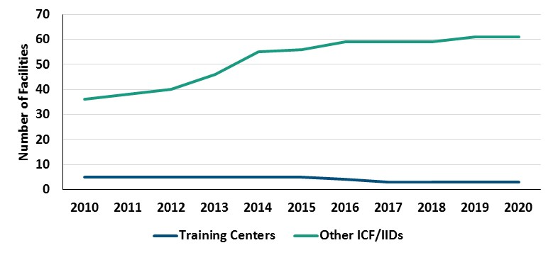
Figure 1: Number of ICF/IID Facilities Over Time, by Facility Type (CMS Quality, Certification, and Oversight Reports database)
Note: This data is collected at the time of each facility’s annual certification survey, and therefore does not represent a single point in time across facilities.

However, this success is mitigated by an increased reliance on other ICF/IIDs. The number of other ICF/IIDs increased by 69 percent, from 36 facilities in 2010 to 61 facilities in 2020. Most of this increase occurred between 2012 and 2014, leading up to the first Training Center closure.

Most of these new facilities were relatively small. The number of ICF/IIDs with one to eight beds increased substantially, from 25 facilities in 2010 to 47 facilities in 2020. Facilities with nine to 16 beds also increased modestly, from eight facilities in 2010 to 11 facilities in 2020. Meanwhile, there were minimal changes in the number of facilities with 17 or more beds.

Few states increased the number of ICF/IIDs to the extent that Virginia did between 2010 and 2020, based on an analysis of the Centers for Medicare & Medicaid (CMS) Quality, Certification, and Oversight Reports database. Only one state – Tennessee – added more ICF/IIDs than Virginia. Tennessee increased from 97 facilities in 2010 to 170 in 2020. Only three states – Tennessee, Nebraska, and South Dakota - had a greater percentage increase in ICF/IID facilities than Virginia. These states, with the exception of Tennessee, had few ICF/IIDs to begin with. Nebraska and South Dakota went from three and one facilities in 2010, respectively, to 13 and three in 2020.

More people live in ICF/IIDs that are not operated by the Commonwealth.
The total number of residents in ICF/IIDs, of any type, has decreased from 1,465 in 2010 to 598 in 2021. This decline is due to the closure of most of the Commonwealth’s Training Centers, which reduced the number of Training Center residents from 1108 in 2010 to 98 in 2020 (see Figure 2). Meanwhile, however, the number of people living in other ICF/IIDs increased by 42 percent. The number of residents in these facilities increased from 357 in 2010 to 508 people in 2020.

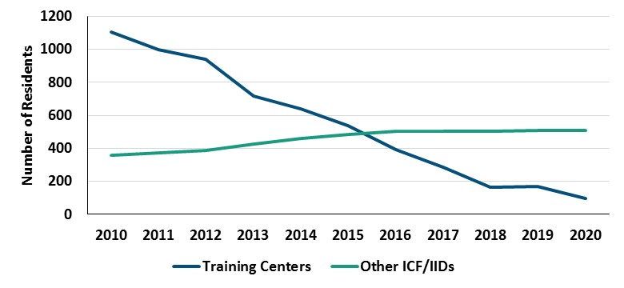
Figure 2: Number of ICF/IID Residents Over Time, by Facility Type (CMS Quality, Certification, and Oversight Reports database)
Note: This data is collected at the time of each facility’s annual certification survey, and therefore does not represent a single point in time across facilities.

State Oversight of ICF/IID Development

The Commonwealth has three primary ways to oversee the development of ICF/IIDs. First, the Commonwealth can actively encourage their development by providing funding and other support. Second, the Virginia Department of Health’s (VDH) Certificate of Public Need (COPN) program authorizes a proposed capital project, prior to implementation, based on its ability to meet criteria that demonstrate public need (see Appendix A). Third, the Board of Behavioral Health and Developmental Services has the authority to establish state regulations that specify a maximum number of service recipients (Va. Code §37.2-409).

Over the past decade, Virginia actively encouraged the development of additional ICF/IIDs.
One reason for the increased utilization of non-state-operated ICF/IIDs in Virginia was the need to quickly accommodate people being discharged from Training Centers. The 2009 Virginia General Assembly authorized approximately $8.5 million in bond funding to develop 12 ICF/IIDs and six group homes to help transition individuals out of Training Centers, per Item C-103.05 of the 2009 Appropriations Act. Additionally, each year since 2013, the state budget has directed DBHDS to encourage ICF/IID development in certain circumstances:

In the event that provider capacity cannot meet the needs of individuals transitioning from training centers to the community, the department shall work with community services boards and private providers to explore the feasibility of developing (i) a limited number of small community group homes or intermediate care facilities to meet the needs of residents transitioning to the community, and/or (ii) a regional support center to provide specialty services to individuals with intellectual and developmental disabilities whose medical, dental, rehabilitative or other special needs cannot be met by community providers.

This development of additional ICF/IIDs enabled many of the people who were discharged from Training Centers to move to another ICF/IID. One hundred (12 percent) of the 841 individuals who had transitioned out of Training Centers by November 13, 2020, had moved to another ICF/IID (DBHDS 2021). These 100 people appear to account for most, but not all, of the increase in the number of residents in non-state-operated ICF/IIDs between 2010 and 2020.

While encouragement of ICF/IID development may have been necessary in the short run, it should not become the status quo in the long run. There is a need to accommodate people who make an informed choice to live in an ICF/IID. However, this need should lessen in the coming years, now that the closure of Training Centers is complete and the Commonwealth continues to expand the availability of home- and community-based alternatives for those who are interested. The Commonwealth should reevaluate its approach to ICF/IID utilization, and its explicit encouragement of their development, accordingly.

Virginia has no restrictions on the development of smaller ICF/IIDs.
State restrictions on the development of ICF/IIDs have evolved over time (see Figure 3). The COPN process evolved from being applicable to all ICF/IIDs, with no limit on facility size, to being applicable only to ICF/IIDs with more than 12 beds and limiting facilities to 20 beds. The licensing regulations evolved from having no limit on facility size to limiting facilities to 12 beds. While both of these mechanisms have tightened restrictions on facility size over time, the COPN process has loosened restrictions on the development of smaller ICF/IIDs.

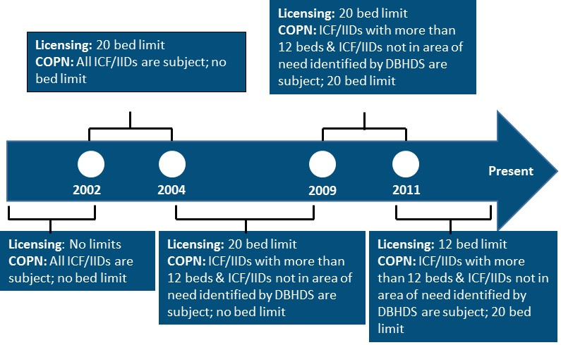
Figure 3: Limitations on ICF/IID Development in Virginia Over Time (Va. Code §32.1-102.1:3, 12 VAC 5-230-870, and 12 VAC 35-105-330)

No ICF/IIDs are currently subject to COPN. The COPN process only applies to facilities that have more than 12 beds, but the licensing regulations prohibit ICF/IIDs from having more than 12 beds. The COPN process also applies to facilities of any size that are not in an area of need identified by any DBHDS plan, but VDH has not been able to identify any such plan.

It would be prudent for the Commonwealth to reinstate the COPN process for ICF/IIDs.
The need to quickly accommodate people with disabilities should lessen, now that the closure of Training Centers is complete, as previously noted. Reinstating the COPN process would support Virginia’s goal of serving people in the most integrated setting, consistent with their informed choice. It would better enable the Commonwealth to focus its limited resources on expanding home- and community-based options so that future placements can be as integrated and as cost-effective as possible.

Some disability organizations have previously called for the reinstatement of the COPN process for ICF/IIDs. In 2012, the Disability Commission recommended that all ICF/IIDs be subject to the COPN process. In 2014, the Virginia Board for People with Disabilities recommended in its Assessment of Virginia’s Disability Services System that new ICF/IIDs with more than six beds, or existing ICF/IIDs expanding by more than six beds, be subject to the COPN process.

Now is a particularly good time for the Commonwealth to revisit the COPN process for ICF/IIDs. The 2020 General Assembly established a Health Services Plan Task Force that will make recommendations by November 2022 regarding methods for evaluating public need in the COPN process (Va. Code § 32.1-102.2:1). The Task Force should take into account recent policy changes including, but not limited to, Virginia’s Settlement Agreement with the U.S. Department of Justice. The COPN criteria pertaining to ICF/IIDs were last revised in 2011, before the Commonwealth entered into the Settlement Agreement (12 VAC 5-230-870).

The Commonwealth may also wish to consider implementing a moratorium on ICF/IIDs. Moratoriums prohibit the granting of a COPN. At least five states have a moratorium on ICF/IIDs: Arkansas, Louisiana, Minnesota, Mississippi, and West Virginia (NCSL, 2019). Virginia has implemented moratoriums in the past for other medical facilities, including nursing homes, but not for ICF/IIDs (Stanton, 2018). A moratorium on ICF/IIDs would allow the Commonwealth to fully focus its limited resources on expanding home- and community-based options so that future placements can be as integrated as possible.

State Oversight of ICF/IID Admissions and Discharges

Virginia has two key opportunities to divert an individual from an ICF/IID to more integrated setting. The first opportunity is prior to admission. Ensuring that someone’s initial service setting is as integrated as possible is paramount because any subsequent moves will disrupt their entire network of services and supports. The second opportunity is to encourage discharge from an ICF/IID. Virginia has implemented several changes to both of these processes in recent years, in order to comply with the U.S. Department of Justice Settlement Agreement.

Recent changes to the ICF/IID admissions process have helped reduce inappropriate admissions.
DBHDS implemented a single point of entry for ICF/IIDs in 2018 to address concerns from the U.S. Department of Justice about inconsistency in screening for ICF/IID admissions and exploration of available community options (Va. Code Commission, 2018). Previously, each non-state-operated ICF/IID had its own application and admissions process (VBPD 2014). Now, DBHDS oversees the administration of the screening tool, called the Virginia Individual Developmental Disability Eligibility Survey, and refers all requests for ICF/IID admission to a Regional Support Team (see Figure 4). The Regional Support Team is responsible for ensuring that the individual is placed in the most integrated setting, consistent with their choice. DBHDS also explores more integrated community options with the individual and their family at the time of screening.

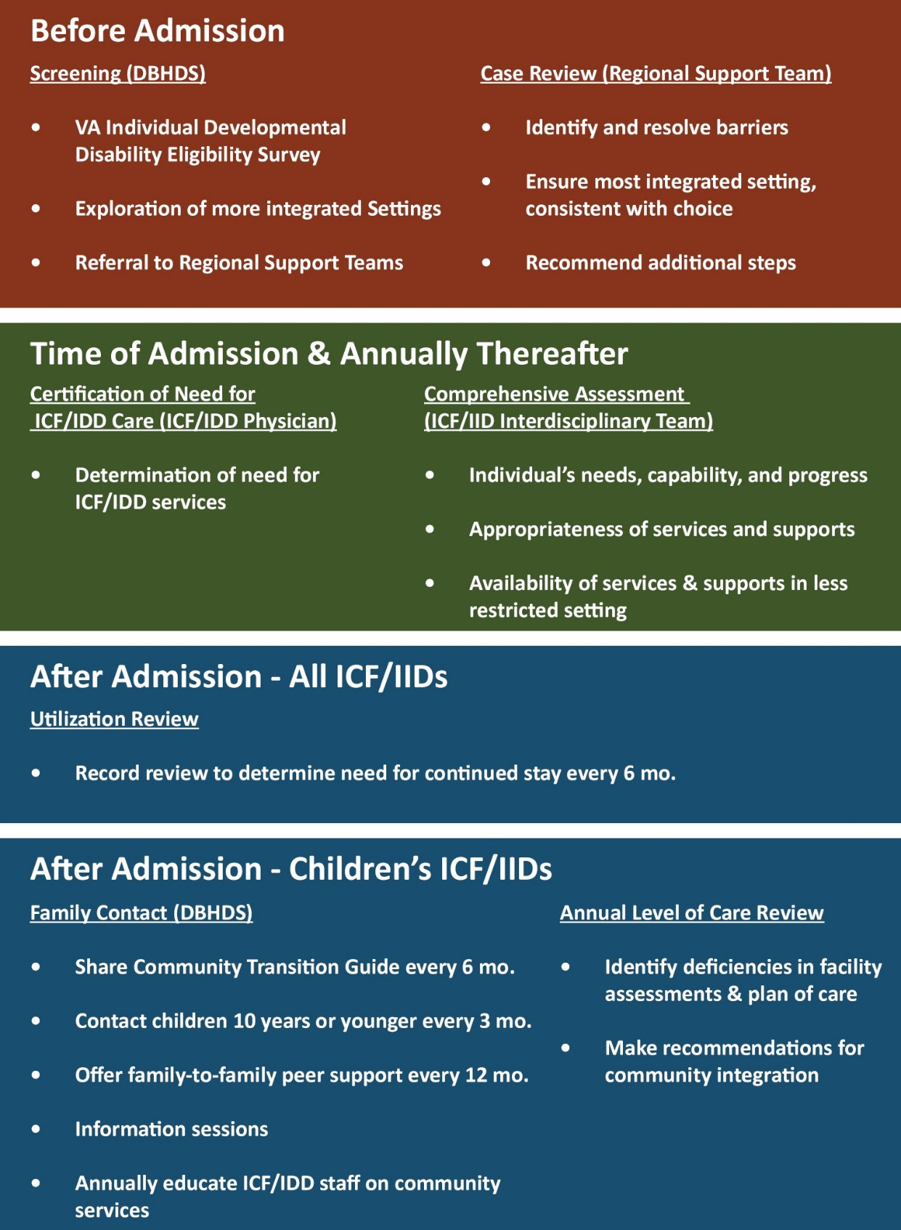

Figure 4: Key Processes for ICF/IID Admissions and Continued Stay (42 CFR §456.350-456.438, 42 CFR §483.440, 12VAC30-60-50, 12VAC30-60-361, DBHDS 2020 Standard Operating Procedures, DMAS 2017 Nursing Facility Provider Manual, and information provided by DMAS and DBHDS staff.
These changes have helped reduce inappropriate admissions to ICF/IIDs. An Independent Reviewer, tasked with tracking Virginia’s compliance with the U.S. Department of Justice Settlement Agreement, acknowledged this progress in his June 2019 report:

The consultant found that the Commonwealth’s processes for diverting children from being placed in these types of institutions is largely in place. These processes, including the single point of entry screening, have effectively diverted children from admission. This effectiveness is limited by a community-based service system that has significant systemic obstacles to receiving needed home-based care (e.g., families and Case Managers know that in-home nurses and direct support professionals are not available to consistently fill the hours that the Commonwealth confirms are needed.)

More recently, the Independent Reviewer’s June 2020 report expressed concern about infants in a particular long-term care hospital being placed directly into a large ICF/IID in the area, without the family being informed of alternative community-based options. Nonetheless, the Commonwealth’s new single point of entry process is a substantial improvement.

Opportunities exist to improve state assurance of adults’ ongoing need and desire for ICF/IID care.
Once an individual is admitted to a facility, the facility is responsible for annually assessing the individual’s need for ICF/IID services (12VAC30-60-361; DMAS 2017). As part of the assessment, facilities are responsible for knowing and reviewing the availability of community alternatives. People with intellectual and developmental disabilities do not receive targeted case management services through Virginia’s State Plan for Medical Assistance.

Historically, state oversight of these ICF/IID processes has been fairly limited. The state is required to conduct two semi-annual utilization reviews, one of which is through the DMAS and the other through the VDH certification process according to 12 VAC 30-10-530. However, DMAS staff report that they are no longer required to conduct their own semi-annual utilization review, following changes to federal guidance in the early 2000’s. Instead, this utilization review is now conducted by the providers themselves. Facilities have to produce documentation of their semi-annual utilization review to DMAS upon request. Additionally, recent federal changes limited the extent to which VDH’s certification process meets the intent of a semi-annual utilization review. VDH is only required to assess the need for active treatment and timeliness of comprehensive assessments when the certification process identifies other violations regarding the provision of active treatment, according to the CMS State Operations Manual. The certification process only reviews a sample of individuals in each facility and does not appear to assess the exploration of community alternatives.

DBHDS recently implemented additional state oversight processes to encourage the discharge of children from ICF/IIDs. DBHDS now regularly contacts family members of children in ICF/IIDs to share information and support regarding alternative services in the community (see Figure 4). DBHDS also conducts Level of Care reviews each year, in which it identifies deficiencies in a facility’s comprehensive assessments and plans of care and informs the facility about community integration options to share with the family during their next assessment.

These changes have helped encourage discharge of children from ICF/IIDs, although additional work is needed. The Independent Reviewer’s June 2019 report shared the following assessment of progress:

To facilitate transitions, the Commonwealth has engaged with the staff at the four facilities included in the consultant’s study. In reviewing the outcomes from this collaboration, the consultant established that the transition of children into more home and community-based settings has occurred at three of the four facilities. Although, the requisite processes appear to be in place and functioning, their effectiveness is limited by the lack of viable community-based options for children. DBHDS reports that there is a current census of 170 children in these four nursing and private ICF facilities. Although, this is a reduction from the census of 196 children reported in 2015, it essentially represents no change in the census of children in these four institutions since our last study in 2017 (171).

Despite their usefulness, these new state oversight processes do not apply to adults in ICF/IIDs. In the absence of state Level of Care reviews for adult ICF/IIDs, there is little assurance that facilities are in compliance with federal and state regulations. Findings from existing state oversight processes indicate that there is a need for careful oversight. VDH certification reviews from FFYs 2014-18 identified six adult ICF/IIDs that failed to conduct or update comprehensive assessments, based on a review of certification reports by the Virginia Board for People with Disabilities (VBPD). DBHDS Level of Care reviews for children’s ICF/IIDs identified late or missing Virginia Individual Developmental Disability Eligibility Surveys and a lack of psychological assessments, for the second and third quarters of state fiscal year 2020.

While it is understandable to prioritize children, given the Commonwealth’s limited resources, the Commonwealth should not overlook adults in ICF/IIDs who may be interested in moving to the community. In the event that the Commonwealth is unable to prevent inappropriate ICF/IID admissions, or the individual’s needs or preferences change over time, it is important that there be mechanisms in place to identify the need for a different setting and discharge the individual in a timely fashion. Relying on facilities to provide this oversight poses a conflict of interest that could jeopardize people’s right to make an informed choice.

The reasons for ongoing admissions to non-state-operated ICF/IIDs, and barriers to discharge from them, are not entirely clear. DBHDS reports quarterly on referrals to Regional Support Teams, including the reasons for the referrals and associated barriers. However, the report does not disaggregate the barrier information by service setting, with the exception of Training Centers, so it is not clear which barriers pertain to people seeking to move to or from other ICF/IIDs. Also, the report does not provide any outcome information beyond the number of closed and pending cases, with the exception of Training Centers. DBHDS reports separately on admissions and discharges for children in ICF/IIDs, but the information is limited and does not address adults. The Independent Reviewer has repeatedly acknowledged that limited community-based services has been a barrier, but more detail is needed to inform policy.

Recommendations to Minimize ICF/IID Utilization

Recommendation 1:
The Virginia General Assembly should amend the Section 32.1-102.1:3 of the Code of Virginia to require ICF/IIDs with more than six beds to obtain a Certificate of Public Need prior to development.

Recommendation 2:
The Virginia General Assembly should amend Section 37.2-315 of the Code of Virginia to specify that the Department of Behavioral Health and Developmental Services’ Comprehensive State Plan should address future demand versus supply for Medicaid residential services for people with disabilities, by type of service including ICF/IIDs. The analysis of future demand and supply should consider the barriers to serving people in home- and community-based settings, and the impact of feasible options for addressing those barriers.

Recommendation 3:
The State Health Services Plan Task Force should consult with the Department of Medical Assistance Services and the Department of Behavioral Health and Developmental Services when identifying recommended Certificate of Public Need criteria for ICF/IIDs in the revised State Health Services Plan.

Recommendation 4:
The State Health Services Plan Task Force should recommend the adoption of, and the Board of Health should adopt, the following Certificate of Public Need criteria for ICF/IIDs in the forthcoming State Health Services Plan for ICF/IIDs:
- Criteria in the current State Medical Facilities Plan, per 12 VAC 5-230-870, amended per Recommendation 24 to reduce the bed limit from 20 to 12;
- The ICF/IID is in an area that needs additional ICF/IID capacity, as identified by the Department of Behavioral Health and Developmental Services’ Comprehensive State Plan amended per Recommendation #2 to include ICF/IIDs;
- The ICF/IID would be consistent with Virginia’s Settlement Agreement with the U.S. Department of Justice to serve individuals in the most integrated setting, consistent with individual choice; and
- The ICF/IID’s operations will enable individuals to fully participate in their communities.

Recommendation 5:
The Department of Behavioral Health and Developmental Services should expand its annual Level of Care Reviews, which are currently conducted for children’s ICF/IIDs, to include all ICF/IIDs.

Recommendation 6:
The Department of Behavioral Health and Developmental Services should expand its annual training on alternative services in the community, which is currently offered to staff at children’s ICF/IIDs, to include all ICF/IIDs so they can adequately conduct their comprehensive assessments and reassessments required per 12 VAC 30-60-361.

Recommendation 7:
The Virginia General Assembly should provide any additional funding necessary for the Department of Behavioral Health and Developmental Services to expand its annual Level of Care Reviews (see Recommendation 5) and annual training on alternative community services (see Recommendation 6), from children’s ICF/IIDs to all ICF/IIDs.

Recommendation 8:
The Department of Behavioral Health and Developmental Services should expand its quarterly Regional Support Team report to include (i) Analysis of the barriers specific to individuals seeking admission to, or discharge from, ICF/IIDs; and (ii) Analysis of the barriers that were resolved, with respect to individuals seeking admission to or discharge from ICF/IIDs, including the percentage resolved by type of barrier and the resulting outcome. DBHDS should continue to make these reports available to the public on its website.

Recommendation 9:
The Virginia General Assembly should require the Virginia Department of Medical Assistance Services, in consultation with the Virginia Department of Behavioral Health and Developmental Services, to submit an annual report on the utilization of community ICF/IIDs that includes the following: (i) the number of ICF/IIDs, by size and ownership type, over time; (ii) the number of ICF/IID residents, by facility size and ownership type, over time; (iii) cost of ICF/IIDs to the state over time, by facility ownership type; (iv) barriers to serving ICF/IID residents in more integrated settings; and (iv) steps taken to address the barriers.

- Minimizing ICF/IID Costs

Virginia has made several efforts to reduce Medicaid spending on ICF/IIDs in recent years, but these efforts have largely overlooked how Medicaid reimburses ICF/IIDs. The Commonwealth has focused primarily on avoiding institutional costs by shifting people from ICF/IIDs to less expensive home- and community-based settings. However, this focus does not address the cost of caring for people who remain in ICF/IIDs. The cost for ICF/IID services varies widely and there is little incentive for providers to provide efficient and effective care. Each dollar that supports inefficient ICF/IID operations could be redirected to home- and community-based services.

Medicaid Reimbursement Rates to ICF/IIDs

Virginia reimburses ICF/IIDs for their costs, subject to some limits described in the next section on rate methodology. Reimbursement rates are calculated on a per person per day basis. This basis allows for a simple comparison across facilities serving a differing number of residents.

Medicaid reimbursement rates varied widely for Virginia’s ICF/IIDs in SFY 2018.
The Medicaid reimbursement rate, per person per day, ranged from $309 at one ICF/IID to $1,304 at a Training Center (see Figure 5). Several factors could explain this variation, including differences in facility size, geographic areas, resident acuity levels, quality of care, ownership type, and efficiency.

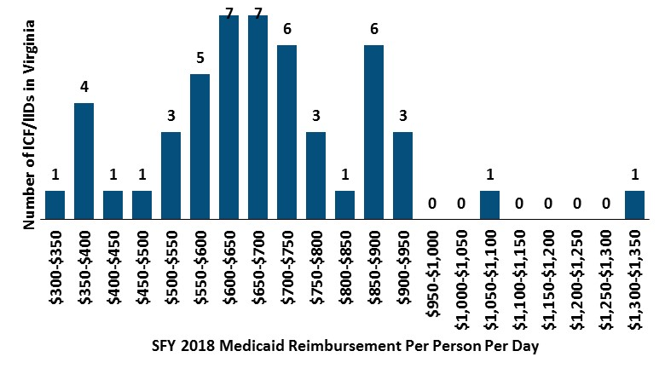
Figure 5: Distribution of Medicaid Reimbursement Rates Across ICF/IIDs in Virginia in SFY 2018 (DMAS Upper Payment Limit Demonstrations to CMS)

The cost of caring for people in ICF/IIDs is higher than caring for them in the other settings. The average reimbursement rates for ICF/IIDs in SFY 2018 translate into an average annual cost of $398,587 per person in Training Centers and $230,943 per person in other ICF/IIDs. Meanwhile, Medicaid services for people who were discharged from Training Centers cost an average of $154,339 per person in SFY 2017. Some of the cost difference is due to the Training Center closure artificially increasing the cost per person, because there were fewer residents to cover the same fixed costs. Some of the cost difference may also be due to different level of care needs, if the Training Center residents who were discharged by that time required a lower level of care. However, at least some of the cost difference likely reflects the increased cost-effectiveness of home- and community-based care.

The average Medicaid reimbursement rate for ICF/IID services has increased in recent years.
The average Medicaid reimbursement, per person per day, for Training Centers increased by 55 percent between state fiscal years (SFY) 2014 and 2018, from $705 to $1,092 respectively (see Figure 6). The average Medicaid reimbursement, per person per day, for other ICF/IIDs increased by 16 percent between SFYs 2014 and 2018, from about $546 to $633 respectively.
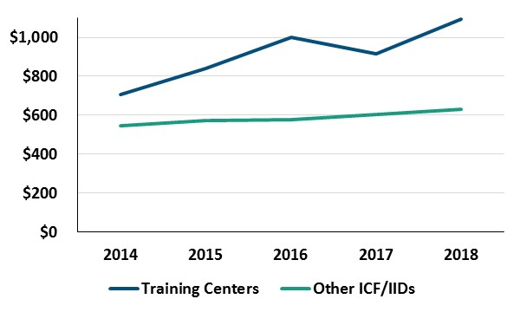
Figure 6: Virginia’s Average Medicaid Reimbursement Rate per Person per Day, by ICF/IID Type (DMAS Upper Payment Limit Demonstrations to CMS)

Several factors may explain these rate increases. First, the price of medical care increased by about 11 percent between SFYs 2014 and 2018, based on the Consumer Price Index for All Urban Consumers. Second, as individuals were being discharged from Training Centers, fewer residents remained but the fixed costs remained the same. Third, the average level of care required for residents in Training Centers and other ICF/IIDs may have increased. This could occur if people with higher care needs were admitted or people with lower care needs were discharged. Fourth, some of the increased rates may have been due to the lack of incentives for efficient and effective care in ICF/IIDs. This factor is discussed in the next section.

Medicaid Reimbursement Rate Methodology

DMAS has wide flexibility to set ICF/IID reimbursement rates. States can establish their own methodology, as long as they “assure that payments are consistent with efficiency, economy, and quality of care” (42 U.S.C. 1396a(a)(30)). Federal regulations further clarify that payments must be “reasonable and adequate to meet the costs that must be incurred by efficiently and economically operated providers to provide services in conformity with applicable State and Federal laws, regulations, and quality and safety standards.” (42 CFR §447.253).

Virginia’s ICF/IID reimbursement rates are not transparent to the public.
States must establish rates via a public process, with opportunity for public review (42 CFR §447.205). While DMAS has provided an opportunity for public input when changes to the rate methodology are made, as required, it does not appear to share the payment rates themselves with the public. VBPD had to request the reimbursement rates from DMAS and was only able to obtain rates for five years. This lack of transparency prevents policymakers and the general public from assessing the adequacy of the rate methodology over time.

Virginia’s ceiling for ICF/IID payment rates may be artificially high.
Virginia reimburses Training Centers based on their reasonable and allowable costs, and reimburses other ICF/IIDs based on their reasonable and allowable costs subject to a ceiling (12 VAC 30-90-10). Prior to 2016, the ceiling was set equal to the highest rate paid to a Training Center in the given state fiscal year. Starting in 2016, the ceiling was fixed to the highest rate paid to a Training Center in SFY 2012, and increased each year by an annual nursing facility inflation factor.

The methodology change resulted in a lower ceiling than it otherwise would have been. The methodology change was in recognition of the fact that per diem costs for Training Centers were increasing artificially as a result of the closures. As individuals were being discharged, fewer residents remained but the fixed costs remained the same. By capping the ceiling at the 2012 ceiling, adjusted for inflation, the ceiling was immune from the escalating costs of Training Centers.

However, the ceiling may still be artificially high. DMAS likely chose 2012 as the base year because that is when the U.S. Department of Justice Settlement Agreement went into effect, after which efforts to transition people from institutions to the community were accelerated. However, the decline in Training Center residents began long before the Settlement Agreement. The number of residents at these facilities decreased gradually from 1,739 in 2000 to 969 in 2012. Therefore, a base year prior to 2012 may have been more appropriate if the goal were to reflect per person costs prior to discharges making them artificially high. Unfortunately, VBPD was not able to obtain historical data on reimbursement rates in order to identify the impact of choosing 2012 as the base year for the ceiling.

Virginia’s ICF/IID reimbursement methodology lacks incentives for cost efficiency.
Federal and state regulations indicate that ICF/IID payments should be tied to cost efficiency, stating that the payments should be based on costs that are “reasonable” and incurred by “efficiently and economically operated providers” (42 CFR §447.253; 12 VAC 30-90-10). However, these requirements are only as good as they are enforced. In the absence of enforcement, providers have no incentive to try to contain their costs as long as they are below the ceiling rate.

The terms “reasonable” and “efficiently and economically operated providers” are not well-defined, limiting the ability of the federal government and states to enforce them. A 2015 Government Accountability Office report raised these very concerns, stating the following:

CMS’s oversight of Medicaid payments to individual hospitals and other institutional providers is limited. The agency does not collect provider-specific payment and ownership information and lacks a policy and standard process for determining whether Medicaid payments to individual providers are economical and efficient. As a result, excessive state payments to individual providers may not be identified or examined by CMS.

The only apparent information on their meaning is in the CMS Provider Reimbursement Manual. The manual states that there is an expectation that the “provider seeks to minimize its costs and that its actual costs do not exceed what a prudent and cost conscious buyer pays for a given item or service.” The manual also states that full costs should be reimbursed “except where a particular institution's costs are found to be substantially out of line with other institutions in the same area which are similar in size, scope of services, utilization, and other relevant factors.” DMAS does not report there being any state definitions of “reasonable.”

Virginia reports having some methods for assessing reasonableness. DMAS conducts periodic field audits to assess whether ICF/IID costs are accurate, allowable, and reasonable (12 VAC 30-90-10). DMAS staff report that 35 percent of ICF/IIDs were subject to a field audit in the past three years. These audits identified, among other things, unsupported costs and the inclusion of unallowable costs such as political lobbying activities. It is not clear, however, how these field audits define or assess reasonableness. DMAS staff also report that they use “reasonableness testing methodologies as recommended by CMS” to assess the reasonableness of each provider’s costs and records. However, DMAS provided no further information on what these testing methodologies are.

In the absence of any additional information, it is not clear that these methods are sufficient for ensuring cost efficiency. DMAS’ field audits and reasonableness testing appear most likely to address the component of reasonableness that regards “what a prudent and cost conscious buyer pays for a given item or service,” per the CMS Provider Reimbursement Manual. However, there is no available information to indicate that Virginia compares costs across institutions, nor adjusts reimbursement rates accordingly, as the manual also recommends. A comparison of ICF/IID costs across institutions is warranted given that reimbursement rates vary widely (see Figure 6). An analysis would need to be done to identify the reasons for the variation and any related implications for payment methodology.

Unlike Virginia, most states appear to have based their reimbursement rates on a comparison of costs across institutions, or other efficiency incentives, according to the most recent information available. As far back as 1993, a report by the U.S. Department of Health and Human Services found that some states were including efficiency incentives in their rate methodology and the “cost controls had not forced cuts in services; rather, they had forced the [facilities] to operate more efficiently.” In 2002 and 2012, Virginia was one of only 11 or so states that reported paying the full reasonable costs of non-state-operated ICF/IIDs (Congressional Research Service 2004; Kaiser Family Foundation 2012). Other states reported incorporating the following into their rate methodology: peer groups based on facility size or location, adjustments for resident acuity levels, or other efficiency incentives.

Recommendations to Minimize ICF/IID Costs

Recommendation 10:
In keeping with the federal requirement that ICF/IID rates be established via a public process, the Department of Medical Assistance Services should add information about ICF/IID rates to their “Rate Setting Information” webpage and regularly update the information when changes occur. At a minimum, the information should include (i) a description of the ICF/IID rate methodology, (ii) rates for each ICF/IID, by facility size, for the most recent year, and (iii) the ceiling for non-state ICF/IID rates for the most recent year.

Recommendation 11:
The Virginia General Assembly should require the Department of Medical Assistance Services to study ICF/IID rates and report its findings to the General Assembly by November 1, 2022. The report should include (i) change over time in ICF/IID rates and possible explanatory factors, (ii) range of ICF/IID rates across facilities and possible explanatory factors, (iii) comparison of ICF/IID rates to the ceiling, as well as the appropriateness of the ceiling, (iv) incentives under the current reimbursement methodology regarding efficiency and effectiveness, (v) reimbursement rates in Virginia compared to other states, (vi) reimbursement methodologies used in other states, and (vii) recommendations for an alternative reimbursement methodology and its potential impact on cost and quality.

- Ensuring Health and Safety in ICF/IIDs

While Virginia is focused on transitioning people with disabilities from institutions to home- and community-based settings, it is important that the Commonwealth focus on ensuring the health and safety of those who remain in institutions. People with disabilities who live in these facilities need a variety of services and supports for daily life. People with disabilities are also at higher risk, compared to people without disabilities, of being abused or neglected and have more difficulty communicating when abuse and neglect happens. If facilities do not provide adequate services and supports, or fail to protect people from abuse and neglect, the residents’ quality of life will seriously suffer.

Providers are required to comply with two main sets of health and safety laws. The first set is federal Medicaid certification laws, which are overseen by VDH. ICF/IIDs must comply with these laws in order to receive Medicaid reimbursement. The second set is state licensure laws, which are overseen by DBHDS. Non-state-operated ICF/IID must comply with these laws in order to operate in Virginia (Va. Code §37.2-405). However, these laws are only as effective as they are enforced, which is dependent on the Commonwealth’s ability to both identify violations and ensure that providers correct violations. If either one of these enforcement steps is not taken, providers have little incentive to comply with related requirements.

Medicaid Certification of ICF/IIDs

In order to be eligible for Medicaid reimbursement, ICF/IIDs must demonstrate compliance with federal Conditions of Participation. The Conditions of Participation address a variety of topics related to care provision including, but not limited, to client protections, facility staffing, facility environment, and service provision (42 C.F.R §483.400-480). ICF/IIDs are also required to comply with Life Safety Code requirements related to the adequacy of the physical facilities including, but not limited to, utilities, fire alarms, and sprinkler systems.

VDH is responsible for annually certifying compliance with the Conditions of Participation via a survey based on a review of facility records, on-site observations, and on-site interviews with residents, their support networks, and facility staff. VDH has historically contracted with the Virginia Department of Fire Programs’ State Fire Marshall’s Office to determine compliance with the Life Safety Code requirements.

In conducting certification surveys, surveyors first conduct a shortened survey and expand their surveys when violations are found. The shortened survey, called a focused fundamental survey, assesses key standards that pertain to each Condition of Participation. See Appendix B for a listing of the key standards associated with each Condition of Participation. When a surveyor finds that a key standard is out of compliance, the state must review all standards that correspond to that key standard. If these findings indicate that one or more Conditions of Participation, as a whole, may be noncompliant, the surveyor can decide to survey all of the standards within the relevant Conditions of Participation via an extended survey or full survey.

Some ICF/IIDs certification findings are concerning due to their frequency and/or nature.
At some facilities, no violations or only one or two relatively minor violations are identified. However, at other facilities, a high number of violations, recurring violations, and/or egregious violations are identified.

The nature of the violations varied substantially in federal fiscal year (FFY) 2018 (see Figure 7). About one-third of the noncompliant standards regarded active treatment. In these cases, the facility typically failed to provide active treatment, the facility did provide active treatment but failed to document it, or facility’s qualified intellectual disability professional failed to regularly review and revise the active treatment plan. Sixteen percent of the noncompliant standards regarded health care services, which typically involved improper medication administration or storage. The most concerning violations pertained to client protections, which accounted for thirteen percent of noncompliant standards. In one notable case, facility staff failed to perform the Heimlich maneuver on a resident who was choking despite being aware of the fact that the individual was choking. In other cases, facility staff failed to provide appropriate supervision, resulting in residents ingesting inedible objects or wandering off facility premises.

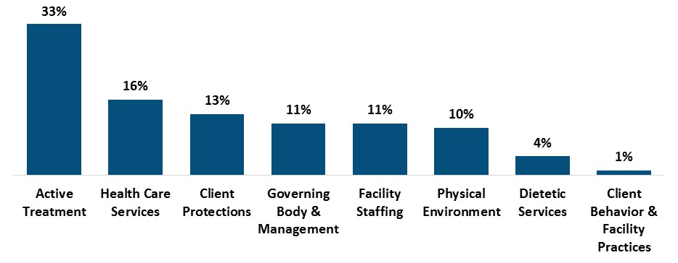
Figure 7: Frequency of Standards Violated in ICF/IIDs in FFY 2018, by Condition of Participation (ICF/IID certification reports provided by VDH)

Certain facilities account for a disproportionately large share of violations each year. The number of standards that were violated per facility in FFY 2018 ranged from zero standards at seven facilities and one standard at 11 facilities, up to 12 standards at one facility. The top five of Virginia’s 62 ICF/IIDs accounted for 34 percent of the standards violated in FFY 2018, and the top ten facilities accounted for 56 percent.

Some violations recurred over time. Based on a review of ICF/IID certification reports by VBPD staff, nearly one in four, or 24 percent, of standards that were noncompliant in FFY 2018 were also noncompliant at the same facilities in at least one of the preceding four years (see Figure 8). Recurrence indicates that the facility did not sufficiently address the cause(s) of the violation after it was first found.
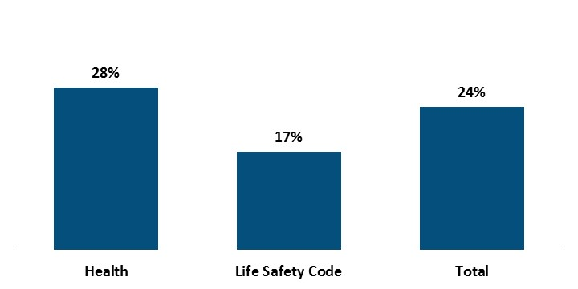
Figure 8: Percent of FFY 2018 Certification Violations that Also Occurred in FFYs 2014-17 at the Same ICF/IID, by Violation Type (ICF/IID certification reports provided by VDH)

The concentration of violations in certain facilities, the severity of some of the violations, and the frequent recurrence of violations indicate that providers may not be adequately incentivized to comply with federal requirements. An annual certification survey of ICF/IIDs is not, in and of itself, effective at ensuring compliance with the Medicaid Conditions of Participation. There must be appropriate consequences tied to the certification process that incentivize ICF/IIDs to correct any violations that are found and proactively comply between certifications.

Virginia has not completed annual ICF/IID certifications on time.
VDH is federally required to conduct these certifications once every 15 months for a given ICF/IID, and once every 12 months on average across all ICF/IIDs (42 C.F.R. §442.109). Twenty ICF/IIDs, accounting for about one-third of all ICF/IIDs, had not had their certifications completed within the past 16 months as of June 20, 2019, prior to the onset of COVID-19 pandemic which temporarily suspended recertifications (CMS QCOR, n.d.).

Virginia had significantly more overdue certifications than other states, as of June 20, 2019. Only two of the 47 other states with ICF/IIDs, Illinois and New York, had a higher number of overdue certifications than Virginia (see Figure 9). Similarly, only two other states, Kansas and Washington, had a higher percentage of certifications that were overdue.
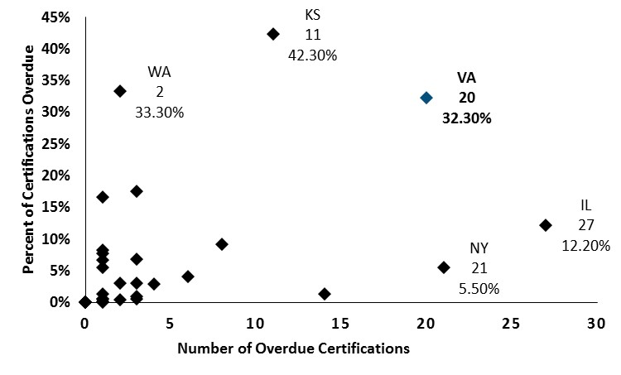
Figure 9: Overdue ICF/IID Certification Reports, by State, as of June 20, 2019 (CMS QCOR, n.d.)

Failure to conduct ICF/IID certifications on time could result in greater risk to the health and safety of people with disabilities living at the ICF/IID. The more time that lapses between certifications, the longer a facility could be in violation of the Conditions of Participation.

VDH staff report that the delayed certification reports were due to staffing challenges that they have since addressed. VDH began requiring all long-term care certification staff to survey ICF/IIDs, whereas it was previously voluntary, and requested federal matching funds to hire additional surveyors. VDH also has a goal of conducing the Life Safety Code survey themselves, rather than contracting with the State Fire Marshall’s Office which has experienced delays following staff turnover. VDH anticipates catching up on the backlog by the time this report is released, but the Commonwealth should continue to carefully monitor their performance moving forward.

Virginia has does not adequately confirm implementation of Plans of Correction.
Federal laws and guidance give states several enforcement tools when a facility is not in compliance with the federal Conditions of Participation or related standards (see Figure 10). The primary enforcement tool is a requirement that ICF/IIDs submit a Plan of Correction when noncompliance is found (42 CFR §442.101).

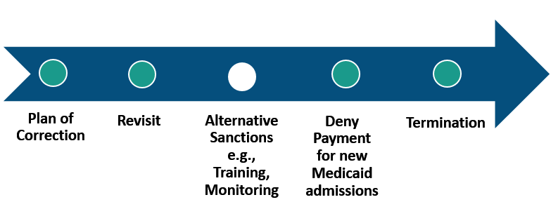
Figure 10: Authorization Status of Enforcement Tools for ICF/IID Certification in Virginia
Note: A filled circle indicates Virginia has authority to use the tool. An unfilled circle indicates Virginia does not have authority to use the tool.

The Plan of Correction must be submitted within 10 calendar days, approved by VDH, and address the following components, according to federal guidance in the State Operations Manual from CMS:

- The plan of correcting the specific deficiency. The plan should address the processes that lead to the deficiency cited;
- The procedure for implementing the acceptable plan of correction for the specific deficiency cited;
- The monitoring procedure to ensure that the plan of correction is effective and that specific deficiency cited remains corrected and/or in compliance with the regulatory requirements; and
- The title of the person responsible for implementing the acceptable plan of correction.

The Plans of Correction from FFY 2018 generally addressed the above components, according to a VBPD review. However, planning to correct a problem is not sufficient in and of itself, because the plan may not be ultimately implemented nor effective.

States have the authority to conduct revisits as needed to verify implementation of the Plans of Correction. When a standard is found to be out of compliance, federal regulations allow states to certify ICF/IIDs that submit an acceptable Plan of Correction. States can condition that certification on one of the following: (i) all violations are corrected, or (ii) the facility has made substantial progress in correcting the deficiencies and has a new plan of correction that is acceptable (42 CFR §442.110). Federal guidance in the CMS State Operations Manual allows states to conduct revisits to assure that the conditions for continued certification are maintained. The guidance also states the following in Section 2732:

The [Survey Agency] follows up on all deficiencies cited in [Plans of Correction]. In some cases, the cited deficiencies may be of a nature that a mail or telephone contact will suffice in lieu of an onsite visit (e.g., the facility agreed to amend its bylaws or written policies). A mail or telephone contact is acceptable as long as the [Survey Agency] has no reason to question the validity of the reported corrections. However, an onsite visit is generally required for deficiencies concerning quality of care. Because the [Long-Term Care] survey process focuses on the care of the resident, revisits are almost always necessary to ascertain whether the deficiencies have indeed been corrected.

When an entire Condition of Participation is out of compliance, and the state has a credible allegation that the facility has come into compliance within a specified timeframe, the CMS State Operations Manual indicates that states are required to conduct revisits.

However, VDH’s verification of whether a Plan of Correction has been implemented appears to be limited. VDH reports that they typically limit revisits to instances in which an immediate jeopardy to residents’ health and safety was found. Consequently, VDH did not conduct any revisits in federal fiscal years 2017 or 2018, and only two revisits in federal fiscal year 2019.

Given the number of violations that were identified in the FFYs 2014-18 certification reports, and the fact that many of them pertained to quality of care, it is concerning that so few revisits were conducted. VDH staff report that they review any areas of noncompliance in the next annual certification survey. However, this approach could enable a facility to continuously violate a regulation, without consequence, as long as it continues to submit acceptable Plans of Correction. Timely follow-up on the Plans of Correction, including in-person visits to observe quality of care when relevant, is essential for determining whether any additional enforcement tools are needed.

Virginia has rarely utilized other enforcement tools beyond Plans of Correction to assure compliance.
In addition to Plans of Correction, the Commonwealth can temporarily deny payment and/or terminate a facility (see Figure 10). States are required to terminate a facility’s certification when

- the violations pose immediate jeopardy to residents’ health and safety, and the facility does not remove the threat within 23 days and come into full compliance within 90 days (42 U.S.C. §1396a(i); 42 C.F.R. §442.117); or
- ICF/IIDs are out of compliance with one or more Condition of Participation, that do not pose immediate jeopardy, and fail to comply within 90 days (CMS State Operations Manual, n.d.).

In lieu of termination, states can deny payment for up to 12 months for all new Medicaid admissions (42 U.S.C. §1396a(i); 42 C.F.R. §442.118). This option is only available for ICF/IIDs that are not compliant with the Conditions of Participation, but do not pose immediate jeopardy, and that fail to correct the violations after 60 days. If the ICF/IID does not come into compliance by the end of the payment denial period, the facility’s Medicaid provider agreement must be terminated.

However, Virginia has not used the enforcement tools of denying payment or terminating certification. No ICF/IIDs in Virginia have been terminated, voluntarily or involuntarily, since FFY 2010 (CMS QCOR, n.d.). Virginia does not appear to have temporarily denied payment to any ICF/IIDs between FFYs 2014-2018, based on a VBPD review of ICF/IID reports from that time period.

One key reason that Virginia has not used these enforcement tools is that VDH rarely identifies violations that pertain to an entire Condition of Participation. Instead, most of the violations pertain to standards within a Condition of Participation. Virginia only cited six condition-level violations between FFYs 2010 and 2020. If these facilities corrected the violations within the required time period, then Virginia was not required to deny payment to them or terminate them.

Virginia has consistently identified far fewer condition-level violations than other states. The number of condition-level violations varies substantially across states, ranging from none in some states to 122 in one state in FFY 2020 (CMS QCOR, n.d.). In most years, Virginia identified no condition-level deficiencies while the national average was between 18 and 24 condition-level violations (see Figure 11). Only three states cited fewer condition-level violations, in total between FFY 2010 and 2020, than Virginia. These three states – Rhode Island, South Dakota, and Wyoming – only had between one and five ICF/IIDs during that time period, far fewer than the 41 to 62 ICF/IIDs that Virginia had during that time.

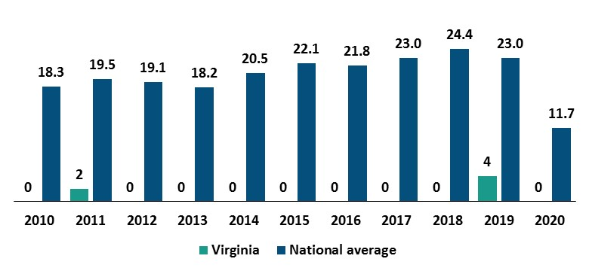
Figure 11: Number of Condition-Level Violations Identified in Certification Reports, Over Time, in Virginia and Nationwide (CMS QCOR, n.d.)
This trend indicates that Virginia may not be identifying all condition-level deficiencies that exist. The lower number of condition-level violations identified in Virginia is not explained by the number of ICF/IIDs, or residents, because Virginia is near the national median on both. Instead, the lower number of condition-level violations is likely due to surveyor discretion. The CMS operational manual provides some guidance to states on how to decide when violations of standards rise to the level of violating the entire Condition of Participation. However, this guidance leaves a lot open to surveyor discretion. Additional training for surveyors on how to identify a condition-level violation would help ensure that surveyors are consistently applying the CMS criteria and maximize VDH’s ability to use enforcement tools when necessary.

Virginia has not established additional enforcement tools that are federally allowable.
The existing enforcement tools, detailed in the last two sections and pictured in Figure 10, are fairly limited. There are tools such as the Plan of Correction that are appropriate for relatively minor violations, and tools such as termination that are appropriate for severe violations, but nothing in between. However, federal laws give states the option to establish additional enforcement tools, known as alternative remedies, that are in lieu of terminating a facility when the violation does not immediately jeopardize health and safety (42 U.S.C. §1396a(i)(B)).

Alternative remedies can include, but are not limited to, directed plan of corrections which are written by the state, directed in-service training, and state monitoring. Federal guidance in the CMS State Operations Manual notes that the ICF/IID would bear the cost of any directed in-service training, although the facility would not be liable to pay the salary of the State monitor. At least two other states, Pennsylvania and Washington, as well as Washington D.C. have established alternative remedies. However, Virginia has not done so.

Other states have identified some limitations to alternative sanctions. A few states that VBPD spoke with noted that the alternative remedies suggested by CMS tend to put the onus for correction on the state. If the state’s directed plan of correction doesn’t adequately prevent future violations, for example, then the state fears that it may be partly to blame. One state emphasized that alternative remedies are just one tool in the toolbox, and that the existing tools can be sufficient if they are effectively utilized.

Nonetheless, the establishment of alternative remedies would give Virginia a much needed continuum of incentives. Alternative remedies would be particularly useful for facilities with violations that are severe enough to warrant more than a Plan of Correction but do not rise to the level of necessitating payment denial or termination. The Commonwealth could issue a remedy that is proportionate to the severity of the facility’s violations. Facilities with a few minor violations could receive less severe remedies than facilities with a high number of violations, recurring violations, or egregious violations.

State Licensure of ICF/IIDs

DBHDS monitors ICF/IIDs for compliance with licensing regulations, and human rights laws listed in Appendix C, in four main ways. First, they conduct at least one unannounced onsite inspection per year, of each service offered by each licensed provider (Va. Code §37.2-411 through 412; 12 VAC 35-105-70; 12 VAC 35-115-260). Second, DBHDS receives and investigates complaints (Va. Code §37.2-411; 12 VAC 35-105-80; 12 VAC 35-115-175). Third, DBHDS monitors and investigates critical incidents in facilities, including, but not limited, to serious injuries and deaths (12 VAC 35-105-160; 12 VAC 35-115-230). Fourth, DBHDS has several committees to oversee quality, including a Developmental Disability Mortality Review Commission that reviews deaths of people with developmental disabilities who received care from licensed providers or Training Centers.

Analyses of licensing and human rights violations in ICF/IIDs are not available to the public.
DBHDS posts inspection and investigation reports to its website. While these reports are a helpful resource, they pertain to individual ICF/IIDs and therefore do not highlight key trends across all ICF/IIDs. DBHDs also publishes a number of summary reports. These summary reports provide some helpful information, but the information has typically been aggregated across multiple service settings with limited analysis of underlying trends and implications.

As DBHDS continues to expand its analysis and reporting, in compliance with the Settlement Agreement, it should not overlook people who remain ICF/IIDs. Oversight findings, and their implications, may vary substantially depending on the service setting. For example, problems that are identified in home- and community-based settings may not necessarily pertain to ICF/IIDs, which are subject to different state and federal laws. Similarly, the method for addressing a problem may depend on which service setting is involved, given that they are subject to different laws. Consequently, having information specific to each service setting is critical to effective monitoring and enforcement.

Available data indicates that smaller ICF/IIDs are not necessarily safer than Training Centers.
State human rights laws require facilities to report allegations of abuse and neglect to DBHDS, as well as the results from their investigation (12 VAC 35-115-175; 12 VAC 35-115-230). VBPD was able to obtain this information for ICF/IIDs, by ownership type, from DBHDS through a data request. Interestingly, this data indicates that abuse and neglect has been more common in non-state-operated ICF/IIDs than in Training Centers over the past decade.

The number of substantiated abuse and neglect allegations, per 100 residents, was typically higher in non-state-operated facilities than in Training Centers (see Figure 12). In 2020, for example, there were over 6 substantiated allegations of abuse or neglect in non-state-operated ICF/IIDs, for every 100 residents, compared to about four in Training Centers. There were only two years, out of the eight years for which data was available, in which the rate of abuse and neglect in non-state-operated ICF/IIDs was lower than in Training Centers. Fortunately, the rate of abuse and neglect has been declining in recent years across all ICF/IIDs.

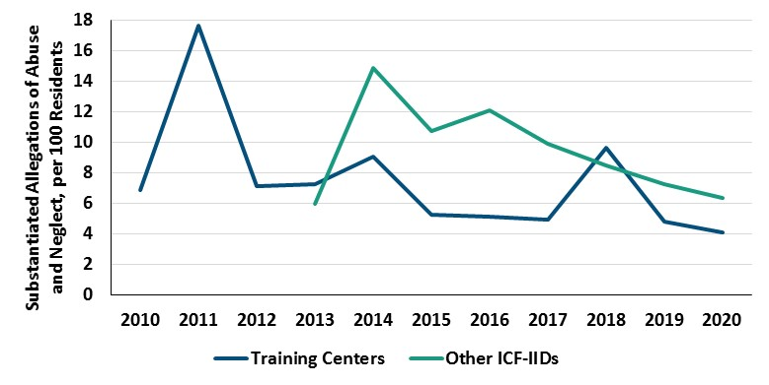
Figure 12: Substantiated Abuse and Neglect Allegations, per 100 residents, in ICF/IIDs by Ownership Type (DBHDS data request on abuse and neglect; CMS Quality, Certification, and Oversight Reports database on number of residents)
Note: Data for other ICF/IIDs prior to 2013 was not available.

This data indicates that more attention to non-state-operated ICF/IIDs is warranted. While smaller institutions are preferable to larger Training Centers, the risk of maltreatment is still present. The Commonwealth should not grow complacent now that the Training Center closures are complete. Instead, the Commonwealth should shift its focus to enforcing a high quality of care in other ICF/IIDs and encouraging discharges from them to home- and community-based settings.

DBHDS’ identification of licensing and human rights violations has been limited, but is improving.
The Independent Reviewer has been closely monitoring DBHDS’ oversight processes for compliance with the U.S. Department of Justice Settlement Agreement and making related recommendations for improvement. The Independent Reviewer has identified problems with the Commonwealth’s ability to identify violations through its inspections, critical incident monitoring, investigations, and mortality reviews. The Commonwealth’s efforts to address these problems are ongoing.

The Commonwealth is inspecting licensed providers at the required frequency, but is not in compliance with the Settlement Agreement’s requirement in Section V.G.3 to assess the “adequacy of supports and services” during these inspections. Specifically, the Settlement Agreement identified eight domains to be assessed: (i) safety and freedom from harm; (ii) physical, mental, and behavioral health and well-being; (iii) avoiding crises; (iv) stability; (v) choice and self-determination; (vi) community inclusion; (vii) access to services; and (viii) provider capacity. DBHDS has developed a checklist to guide this assessment. However, the Independent Reviewer’s December 2020 report concluded that, in most cases, the checklist “…does not include the questions that the assessment seeks to answer, nor what answers will lead to a determination that services are adequate.” DBHDS is continuing to make improvements to its inspection process in order to come into compliance.

The Commonwealth has also added processes to ensure that providers are reporting critical incidents, although additional work remains to comply with the Settlement Agreement. DBHDS began reviewing Medicaid claims data to identify emergency room visits and hospitalizations that providers did not report. This review found that up to 10 percent of serious incidents were not reported, according to the December 2020 Independent Reviewer report. DBHDS failed to identify whether Training Centers were involved in these unreported incidents and failed to cite the providers involved. DBHDS also began reviewing a sample of provider human rights investigations on a semi-annual basis, which the December 2019 Independent Reviewer report described as a “well-done, quality review which has become increasingly effective at discovery and remediation efforts.” This review identified that a significant number of providers were not reporting human rights incidents in a timely fashion.

DBHDS has relied heavily on providers to investigate critical incidents, posing a conflict of interest. DBHDS staff, and the human rights advocates they appoint to monitor human rights in licensed provider settings, have the option to conduct their own investigation. However, DBHDS protocols do not specify criteria to guide the human rights advocate’s decision and only specify limited criteria to guide DBHDS staff’s decision to investigate alleged abuse or neglect. Most investigations were carried out by the provider and submitted to DBHDS for review and closure, as of the December 2019 Independent Reviewer report. A DBHDS semi-annual review identified that a significant number of providers were failing to archive evidence from investigations, which the December 2019 Independent Reviewer report said “indicates a lack of standards, monitoring or enforcement regarding minimum quality standards for how investigations should be implemented and documented.”

Nonetheless, the Commonwealth has made several improvements to come into compliance with the Settlement Agreement’s requirement to investigate critical incident reports. DBHDS created a specialized Investigations Unit and Incident Management Unit, increased the number of investigators, added regional managers, and provided relevant training, according to the December 2019 Independent Reviewer report. These changes resulted in improved consistency, enhanced trend analysis, heightened scrutiny of underperforming providers, and more robust documentation to withstand administration and legal appeals. DBHDS was immediately conducting an investigation if there was concern of abuse or neglect or a concern of an imminent and substantial threat to the health, safety, and welfare of other individuals, as of the December 2020 Independent Reviewer report. As the Investigations Unit receives more resources, DBHDS plans to expand its investigations to include all incidents involving people with developmental disabilities, according to DBHDS’ FY 2020 Quality Management Plan.

DBHDS has also improved the effectiveness of its Developmental Disability Mortality Review Committee, though additional work remains. The Committee made substantial progress regarding data collection and analysis, membership and attendance, and the process and quality of its mortality reviews, according to the Independent Reviewer’s December 2019 report. However, the Committee is not yet in compliance with the Settlement Agreement, mainly due to the need to better address unknown causes of death and identify and reduce preventable deaths.

DBHDS enforcement of licensing and human rights laws has been limited, but is improving.
The Independent Reviewer has also been closely monitoring DBHDS’ oversight processes for compliance with the U.S. Department of Justice Settlement Agreement and making related recommendations for improvement. The Independent Reviewer has identified problems with the Commonwealth’s ability to correct violations and prevent their recurrence, using available enforcement tools. The Commonwealth’s efforts to address these problems are ongoing.

Once a violation of the licensing or human rights regulations is identified, DBHDS has four key enforcement tools available to correct it (see Figure 13). First, the provider must submit a corrective action plan to DBHDS for approval and then implement the plan (12 VAC 35-105-170). Second, DBHDS can issue a provisional license when the provider “has demonstrated an inability to maintain compliance with regulations,…has multiple violations of human rights or licensing regulations, or has failed to comply with a previous corrective action plan” (Va. Code §37.2-415; 12 VAC 35-105-50). Third, DBHDS can impose various sanctions by issuing a “special order” when a licensing violation “adversely affects the human rights of individuals, or poses an imminent and substantial threat to the health, safety or welfare of individuals” (Va. Code §37.2-419; 12 VAC 35-105-100). Fourth, DBHDS can revoke or suspend a license at any time when a provider violates any licensing or human rights regulation, participates in an illegal act, or has “conduct or practices detrimental to the welfare” of any recipient (Va. Code §37.2-418).

Figure 13: Key Enforcement Tools Available for State Licensure & Human Rights Violations (Va. Code §37.2-415 through 419; 12 VAC 35-105-50; 12 VAC 35-105-100; 12 VAC 35-105-170)

DBHDS has improved its use of Corrective Action Plans, but additional work remains. DBHDS recently began routinely requiring providers to both correct the immediate problem and implement changes to prevent recurrence, according to the December 2019 Independent Reviewer report. DBHDS also began routinely confirming implementation of remedial actions for certain health and safety violations in a timely fashion. However, there were some instances in which DBHDS accepted insufficient Corrective Action Plans. Additionally, DBHDS did not confirm that corrective actions regarding a provider’s failure to report had achieved their intended outcome, according to the December 2020 Independent Reviewer report.

DBHDS has been reluctant to utilize enforcement tools beyond the Corrective Action Plan. An Independent Reviewer’s report from December 2018 stated the following:

There is no evidence to contraindicate the view that there is a continuing systemic reluctance by DBHDS to pursue the use of corrective tools at their disposal. The heavy due process burden placed on Licensing Specialists may be the source of this reluctance to consider taking corrective actions beyond [Corrective Action Plans]. Regardless of the rationale, [the Office of Licensing] has failed to use all the tools that it has available for sanctioning providers, which results in marginal providers continuing to operate services. It is doubtful that the paths of using provisional status and provider self-selection to close settings are sufficient for effective management of the problems of the minority of providers who deliver services that do not consistently meet standards.

These concerns were reiterated in the Independent Reviewer’s December 2019 report, which also included a suggestion that the agency consider developing a toolbox for licensing specialists to address providers who are not performing well. DBHDS’ reluctance to enforce the licensing and human rights laws jeopardizes the health and safety of individuals receiving care.

Recommendations for Ensuring Health and Safety in ICF/IIDs

Recommendation 12:
The Virginia Department of Health should ensure that certification and re-certification surveys for intermediate care facilities for individuals with intellectual disabilities are conducted within the federally required timeframes in 42 C.F.R. §442.109.

Recommendation 13:
The Virginia Department of Health should condition certain ICF/IID certifications on one of the following, as allowed per 42 CFR §442.110, with approval from the Centers for Medicare & Medicaid Services as needed: (i) all deficiencies are corrected, or (ii) the facility has made substantial progress in correcting the deficiencies and has a new plan of correction that is acceptable. This approach should be taken for facilities with the most egregious violations in terms of number of deficiencies in a given year, frequency of deficiencies over time, and/or nature of the violation. VDH should then verify whether these facilities have corrected the deficiencies, per Recommendation 14, including on-site reviews when deficiencies involve quality of care.

Recommendation 14:
The Virginia Department of Health should verify that ICF/IIDs have implemented their Plans of Correction, via desk reviews and/or on-site visits as warranted by the nature of the violation. At a minimum, verification should be done for
- facilities with the most egregious violations in terms of number of deficiencies in a given year, frequency of deficiencies over time, and/or nature of the violation. Certification for these facilities should be conditioned on correcting the deficiencies per Recommendation 13; and
- a randomly selected sample of the remaining ICF/IIDs.
On-site reviews should be conducted for deficiencies involving the quality of care, as stated in the Centers for Medicare & Medicaid Services’ State Operations Manual.

Recommendation 15:
The Virginia Department of Health should provide additional training to ICF/IID certification surveyors on how to identify condition-level deficiencies. This training should be included in initial training for surveyors, as well as periodic refresher training.

Recommendation 16:
The Virginia Department of Medical Assistance Services should, in consultation with the Virginia Department of Health, seek approval from the Centers for Medicare & Medicaid Services to
- Establish alternative remedies for certification of intermediate care facilities for individuals with intellectual disabilities (ICF/IID) in its State Plan for Medical Assistance, per Section 3006 of the Centers for Medicare & Medicaid Services’ State Operations Manual. The Department should consider including the following remedies, at a minimum: directed plans of correction, in-service training, and state monitoring. The criteria for implementing these remedies should be (a) based, at least in part, on the number of deficiencies in a given year, frequency of deficiencies over time, and/or nature of deficiencies at the ICF/IID, and (b) align with the Department of Behavioral Health and Developmental Services’ enforcement tools per Recommendation 26.
- Impose the alternative remedies, established in (a), in proportion to the severity of deficiencies at an ICF/IID in accordance with the State Plan for Medical Assistance. The severity of the facility’s deficiencies should consider, at a minimum, the number of deficiencies in a given year, frequency of deficiencies over time, and/or the nature of the deficiencies in a given year.

Recommendation 17:
The Virginia Department of Health should annually review a sample of ICF/IID certification reports to identify opportunities for improved identification and correction of deficiencies. The review should assess, at a minimum, whether
- all relevant deficiencies were reviewed and cited, based on information available in the certification report;
- the surveyor used adequate judgment in deciding whether to conduct a focused versus extended versus full survey;
- the surveyor used adequate judgment in deciding whether to cite standard-level versus condition-level deficiencies;
- the Plan of Correction was adequate;
- the implementation and effectiveness of the Plan of Correction was adequately evaluated; and
- appropriate enforcement tools, beyond the Plan of Correction, were utilized as needed.
The Department should take appropriate action, including, but not limited, to providing additional training to surveyors, in order to address any opportunities for improvement that were identified.

Recommendation 18:
The Virginia General Assembly should provide any additional funding necessary for the Virginia Department of Health to certify intermediate care facilities for individuals with intellectual disabilities within the federally required timeframes (see Recommendation #12), verify implementation of related Plans of Correction (see Recommendations #13 and 14), impose alternative remedies (see Recommendation #16), and conduct an annual review of the certification process (see Recommendation #17).

Recommendation 19:
The Virginia Department of Behavioral Health and Developmental Services should expand its annual reporting to provide a breakdown of information by service setting, including information specific to ICF/IIDs. Relevant reports include but are not limited to Annual Reports to the Governor and General Assembly per Section 37.2-304 of the Code of Virginia, Annual Mortality Reports, Annual Risk Management Review Committee Reports, and Annual Quality Management Reports per Section V.D.6 of the Settlement Agreement. Information specific to ICF/IIDs should include an assessment of
- Percentage of critical incidents, by type, that were investigated by the DBHDS Human Rights staff, including human rights advocates, and/or DBHDS licensing staff;
- Key trends in the nature and frequency of licensing and human rights violations, across state-operated and non-state-operated ICF/IIDs over time, and the implications of these trends; and
- Related enforcement actions that were taken and their impact.

Recommendation 20:
The Department of Behavioral Health and Developmental Services should provide clear criteria in its agency protocols regarding when Human Rights Advocates should actively participate in an investigation of an alleged human rights violation. When resources are limited, the criteria should prioritize human rights incidents based on severity, frequency of occurrence, and facilities with a history of noncompliance with human rights regulations. When resources allow, the protocol should direct human rights advocates to actively participate in all human rights investigations.

Recommendation 21:
The Department of Behavioral Health and Developmental Services should expand criteria in its agency protocols regarding when the Office of Licensing should conduct an investigation of critical incidents. When resources are limited, the criteria should prioritize critical incidents based on severity, frequency of occurrence, and facilities with a history of noncompliance with licensing regulations. When resources allow, the protocol should direct DBHDS staff to actively participate in all licensing investigations.

- Improving Coordination of ICF/IID Oversight

Virginia’s oversight of ICF/IIDs is fragmented across three state agencies. DMAS, VDH, and DBHDS share oversight of ICF/IID utilization, payment, and quality of care (see Figure 14). These processes appear to operate largely in isolation of each other, even though information from one process might inform another process. This fragmentation jeopardizes the Commonwealth’s ability to effectively oversee ICF/IIDs.

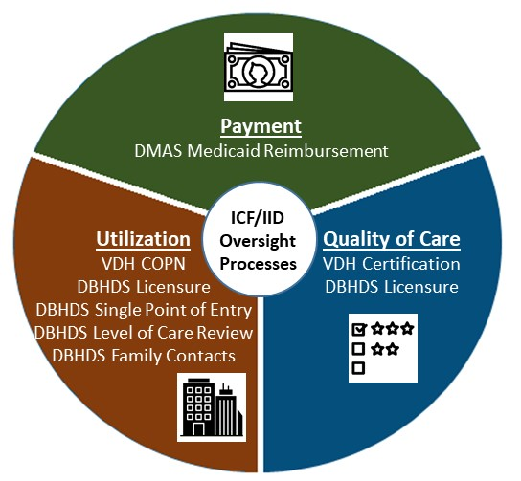
Figure 14: Key ICF/IID Oversight Processes in Virginia

Agencies should make every effort to coordinate their oversight activities in order to ensure their combined effectiveness and identify any gaps in oversight. While privacy concerns may prevent agencies from sharing information regarding specific individuals, they should be able to share high-level findings at a minimum. As the State Medicaid Agency, DMAS has responsibility for overall oversight of ICF/IIDs and should therefore play a central role in coordination.

Fragmented Oversight of ICF/IID Utilization

VDH and DBHDS separately oversee the development of ICF/IIDs in two key ways. First, they both set limits on facility size. These limits currently do not align because DBHDS limits licensed ICF/IIDs to 12 beds but VDH’s Certificate of Public Need program limits them to 20 beds. Second, VDH has the authority to approve or disapprove development of a new medical facility through the Certificate of Public Need program. However, the Certificate of Public Need program is currently moot for ICF/IIDs because it is only applicable to (i) facilities with more than 12 beds, which DBHDS does not allow to be licensed; and (ii) facilities that are in an area of need identified by DBHDS plans, but VDH has not been able to identify any such plan.

Increased coordination between VDH and DBHDS would improve state oversight of ICF/IID utilization. VDH and DBHDS should work together to align their limits on facility size and collectively decide which facilities should be subject to the Certificate of Public Need process. They should also work together to develop a plan for ICF/IID utilization and apply the plan to the Certificate of Public Need process.

Fragmented Oversight of ICF/IID Payment

Medicaid reimbursement for ICF/IIDs is supposed to be contingent on findings from utilization and quality of care reviews. DMAS is not allowed to reimburse ICF/IIDs for individuals who do not meet the eligibility criteria (12 VAC 30-60-50; 12 VAC 30-60-361). DMAS is also not allowed to reimburse ICF/IIDs for individuals who are not receiving appropriate active treatment (42 CFR §440.150; 12 VAC 30-60-50; 12 VAC 30-60-361).

However, it is not clear whether DMAS uses information from the utilization and quality of care reviews to inform payment. There is no information publicly available to indicate that DMAS has ever withheld payments from ICF/IIDs. Given that the VDH and DMAS oversight activities have identified providers who fail to provide active treatment, or adequately assess a resident’s need for continued stay, it is concerning that payment may not have been withheld. DMAS should strongly consider this information when deciding whether to authorize payment.

Fragmented Oversight of ICF/IID Quality of Care

VDH and DBHDS separately oversee ICF/IID quality of care. VDH is responsible for annually certifying that each ICF/IID meets federal Conditions of Participation, which largely address the health and safety of residents. DBHDS ensures that ICF/IIDs comply with licensing regulations that address, among other things, the protection of human rights. These processes operate independently of each other, according to VDH and DBHDS staff, although VDH staff report that they share certification reports with DBHDS and DMAS.

Increased coordination between VDH and DBHDS might improve the quality of care in ICF/IIDs. VDH and DBHDS should regularly update each other on their findings, identify trends in their findings, align their incentives to provide quality care, and address any gaps in oversight. The consequences to an ICF/IID for providing insufficient care may vary depending on the agency, especially given that each agency is not operating with full information. For a given problem, an ICF/IID may be penalized by several agencies, penalized by one agency but not another, or not penalized at all because each agency thinks another agency is addressing it. Consequently, it is not clear what the net incentives are for ICF/IIDs to provide high-quality care.

Recommendations to Improve Coordination of ICF/IID Oversight

Recommendation 22:
The Virginia General Assembly should establish a workgroup to facilitate ICF/IID oversight that includes staff from the Virginia Department of Medical Assistance Services, Virginia Department of Health, Virginia Department of Behavioral Health and Developmental Services, and disAbility Law Center of Virginia. The group should meet at least twice per year to share findings and concerns from their ICF/IID oversight activities, identify barriers to and gaps in oversight activities, and produce an annual report described in Recommendation 23.

Recommendation 23:
The Virginia General Assembly should require the Department of Medical Assistance Services, in consultation with the Virginia Department of Behavioral Health and Developmental Services and the Virginia Department of Health, to submit an annual report on quality of care at ICF/IIDs that includes (i) a summary of all state oversight activities pertaining to ICF/IID during year; (ii) a summary of findings from the oversight activities, including the number, frequency, and nature of identified problems; and (iii) trends over time in the conduct and findings of oversight activities; (iv) steps that were taken to address any undesirable findings, and additional steps that could be taken to address them; and (v) any barriers to, and gaps in, overseeing ICF/IIDs and steps that can be taken to address these barriers.

Recommendation 24:
In its identification of Certificate of Public Need criteria for ICF/IIDs per Recommendation 4, the State Health Services Plan Task Force should recommend the adoption of, and the Board of Health should adopt, a 12-bed limit for ICF/IIDs. This limit would align with the Board of Behavioral Health and Developmental Services’ 12-bed limit per 12 VAC 35-105-330.

Recommendation 25:
The Virginia Department of Health should verify the number of ICF/IID licensed beds with the Department of Behavioral Health and Developmental Services, prior to processing any changes to the number of beds through the certification process or the Certificate of Public Need Process.

Recommendation 26:
The Department of Medical Assistance Services should align the alternative remedies that it establishes for the ICF/IID certification process, per Recommendation 16, with the enforcement tools in the Department of Behavioral Health and Developmental Services’ licensure process.

Appendix A: Certificate of Public Need Criteria for ICF/IIDs

Criteria for all projects required to obtain a Certificate of Public Need, according to Section 32.1-102.3 of the Code of Virginia:

B. In determining whether a public need for a project has been demonstrated, the Commissioner shall consider:

- The extent to which the proposed project will provide or increase access to health care services for people in the area to be served and the effects that the proposed project will have on access to health care services in areas having distinct and unique geographic, socioeconomic, cultural, transportation, and other barriers to access to health care;

- The extent to which the proposed project will meet the needs of people in the area to be served, as demonstrated by each of the following: (i) the level of community support for the proposed project demonstrated by people, businesses, and governmental leaders representing the area to be served; (ii) the availability of reasonable alternatives to the proposed project that would meet the needs of people in the area to be served in a less costly, more efficient, or more effective manner; (iii) any recommendation or report of the regional health planning agency regarding an application for a certificate that is required to be submitted to the Commissioner pursuant to subsection B of § 32.1-102.6; (iv) any costs and benefits of the proposed project; (v) the financial accessibility of the proposed project to people in the area to be served, including indigent people; and (vi) at the discretion of the Commissioner, any other factors as may be relevant to the determination of public need for a proposed project;

- The extent to which the proposed project is consistent with the State Health Services Plan;

- The extent to which the proposed project fosters institutional competition that benefits the area to be served while improving access to essential health care services for all people in the area to be served;

- The relationship of the proposed project to the existing health care system of the area to be served, including the utilization and efficiency of existing services or facilities;

- The feasibility of the proposed project, including the financial benefits of the proposed project to the applicant, the cost of construction, the availability of financial and human resources, and the cost of capital;

- The extent to which the proposed project provides improvements or innovations in the financing and delivery of health care services, as demonstrated by (i) the introduction of new technology that promotes quality, cost effectiveness, or both in the delivery of health care services; (ii) the potential for provision of health care services on an outpatient basis; (iii) any cooperative efforts to meet regional health care needs; and (iv) at the discretion of the Commissioner, any other factors as may be appropriate; and

- In the case of a project proposed by or affecting a teaching hospital associated with a public institution of higher education or a medical school in the area to be served, (i) the unique research, training, and clinical mission of the teaching hospital or medical school and (ii) any contribution the teaching hospital or medical school may provide in the delivery, innovation, and improvement of health care services for citizens of the Commonwealth, including indigent or underserved populations.

Criteria specific to ICF/IIDs that are required to obtain a Certificate of Public Need, according to 12 VAC 5-230-870:

The establishment of new ICF/MR facilities with more than 12 beds shall not be authorized unless the following conditions are met:

- Alternatives to the proposed service are not available in the area to be served by the new facility;

- There is a documented source of referrals for the proposed new facility;

- The manner in which the proposed new facility fits into the continuum of care for the mentally retarded is identified;

- There are distinct and unique geographic, socioeconomic, cultural, transportation, or other factors affecting access to care that require development of a new ICF/MR;

- Alternatives to the development of a new ICF/MR consistent with the Medicaid waiver program have been considered and can be reasonably discounted in evaluating the need for the new facility;

- The proposed new facility will have a maximum of 20 beds and is consistent with any plan of the Department of Mental Health, Mental Retardation and Substance Abuse Services and the mental retardation service priorities for the catchment area identified in the plan;

- Ancillary and supportive services needed for the new facility are available; and

- Service alternatives for residents of the proposed new facility who are ready for discharge from the ICF/MR setting are available.

Appendix B: Medicaid Conditions of Participation and Key Standards for ICF/IIDs
Condition of Participation | Key Standard(s) Assessed in Focused Certification Survey
Active Treatment | Within 30 days after admission, the interdisciplinary team must prepare for each client an individual program plan  As soon as the interdisciplinary team has formulated a client’s individual program plan, each client must receive a continuous active treatment program consisting of needed interventions and services in sufficient number and frequency to support the achievement of the objectives identified in the individual program plan  The individual program plan must be reviewed at least by a qualified intellectual disabilities professional and revised as necessary, including, but not limited to, situations in which the client has successfully completed an objective or objectives identified in the individual program plan
Client Behavior and Facility Practices | The facility policies and procedures must promote the growth, development, and independence of the client  Facility procedures must ensure prior to the use of more restrictive techniques, that the client’s record documents that programs incorporating the use of less intrusive or more positive techniques have been tried systematically and demonstrated to be ineffective  Interventions to manage inappropriate client behavior must be employed with sufficient safeguards and supervision to ensure that the safety, welfare and civil and human rights of clients are adequately protected  The facility may employ physical restraint only as integral part of an individual program plan that is intended to lead to less restrictive means of managing and eliminating the behavior for which the restraint is applied  The facility must not use drugs in doses that interfere with the individual client’s daily living activities
Client Protections | Ensure that clients are not subjected to physical, verbal, sexual or psychological abuse or punishment  Provide each client with the opportunity for personal privacy  Ensure that clients have the right to retain and use appropriate personal possessions and clothing
Dietetic Services | Each client must receive a nourishing, well balanced, diet including modified and specially prescribed diets  Food must be served in appropriate quantity  Food must be served at appropriate temperature  Food must be served in a form consistent with the developmental level of the client  Food must be served with appropriate utensils
Facility Staffing | Each client’s active treatment program must be integrated, coordinated and monitored by a qualified intellectual disability professional  The facility must provide sufficient direct care staff to manage and supervise clients in accordance with their individual program plans
Governing Body and Management | N/A, not part of the focused survey
Health Care Services | The facility must provide or make arrangements for comprehensive diagnostic and treatment services for each client from qualified personnel, including licensed dentists and dental hygienists either through organized dental services in-house or through arrangement  A pharmacist with input from the interdisciplinary team must review the drug regimen of each client at least quarterly  The facility must keep all drugs and biologicals locked except when being prepared for administration
Physical Environment | The facility must not house clients of grossly different ages, developmental levels, and social needs in close physical or social proximity unless the housing is planned to promote the growth and development of all those housed together  The facility must provide each client with a separate bed of proper size and height for the convenience of the client  The facility must provide toilet and bathing facilities appropriate in number, size, and design to meet the needs of the clients  The facility must provide sufficient space and equipment in dining, living, health services, recreation, and program areas (including adequately equipped and sound treated areas for hearing and other evaluations if they are conducted in the facility) to enable staff to provide clients with needed services, as required by this subpart and as identified in each client’s individual program plan  There must be an active program for the prevention, control, and investigation of infection and communicable diseases

Appendix C: Rights of Individuals Receiving Services from Licensed Providers

§ 37.2-400. Rights of individuals receiving services.

A. Each individual receiving services in a hospital, training center, other facility, or program operated, funded, or licensed by the Department, excluding those operated by the Department of Corrections, shall be assured his legal rights and care consistent with basic human dignity insofar as it is within the reasonable capabilities and limitations of the Department, funded program, or licensee and is consistent with sound therapeutic treatment. Each individual admitted to a hospital, training center, other facility, or program operated, funded, or licensed by the Department shall:
1. Retain his legal rights as provided by state and federal law;
2. Receive prompt evaluation and treatment or training about which he is informed insofar as he is capable of understanding;
3. Be treated with dignity as a human being and be free from abuse or neglect;
4. Not be the subject of experimental or investigational research without his prior written and informed consent or that of his legally authorized representative;
5. Be afforded an opportunity to have access to consultation with a private physician at his own expense and, in the case of hazardous treatment or irreversible surgical procedures, have, upon request, an impartial review prior to implementation, except in case of emergency procedures required for the preservation of his health;
6. Be treated under the least restrictive conditions consistent with his condition and not be subjected to unnecessary physical restraint and isolation;
7. Be allowed to send and receive sealed letter mail;
8. Have access to his medical and clinical treatment, training, or habilitation records and be assured of their confidentiality but, notwithstanding other provisions of law, this right shall be limited to access consistent with his condition and sound therapeutic treatment;
9. Have the right to an impartial review of violations of the rights assured under this section and the right of access to legal counsel;
10. Be afforded appropriate opportunities, consistent with the individual's capabilities and capacity, to participate in the development and implementation of his individualized services plan; and
11. Be afforded the opportunity to have a person of his choice notified of his general condition, location, and transfer to another facility.
The Board shall adopt regulations to implement the provisions of this subsection after due notice and public hearing, as provided for in the Administrative Process Act (§ 2.2-4000 et seq.).
B. The Board shall adopt regulations delineating the rights of individuals receiving services with respect to nutritionally adequate diet; safe and sanitary housing; participation in nontherapeutic labor; attendance or nonattendance at religious services; participation in treatment decision-making, including due process procedures to be followed when an individual may be unable to make an informed decision; notification of a person of his choice regarding his general condition, location, and transfer to another facility; use of telephones; suitable clothing; possession of money and valuables; and related matters.
C. The human rights regulations shall be applicable to all hospitals, training centers, other facilities, and programs operated, funded, or licensed by the Department; these hospitals, training centers, other facilities, or programs may be classified as to population served, size, type of services, or other reasonable classification.
D. The Board shall adopt regulations requiring public and private facilities and programs licensed or funded by the Department to provide nonprivileged information and statistical data to the Department related to (i) the results of investigations of abuse or neglect, (ii) deaths and serious injuries, (iii) instances of seclusion and restraint, including the duration, type, and rationale for use per individual receiving services, and (iv) findings by state or local human rights committees or the Office of Human Rights in the Department of human rights violations, abuse, or neglect. The Board's regulations shall address the procedures for collecting, compiling, encrypting, and releasing the data. This information and statistical data shall be made available to the public in a format from which all information identifying a provider or an individual receiving services has been removed. The Board's regulations shall specifically exclude all proceedings, minutes, records, and reports of any committee or nonprofit entity providing a centralized credentialing service that are identified as privileged pursuant to § 8.01-581.17.

Works Cited

Centers for Medicare & Medicaid Services (CMS). “State Operations Manual.” Publication no. 100-07, accessed March 16, 2021. https://www.cms.gov/Regulations-and-Guidance/Guidance/Manuals/Internet-Only-Manuals-IOMs-Items/CMS1201984.html.

Centers for Medicare & Medicaid Services (CMS). Quality, Certification, and Oversight Reports (QCOR). Accessed March 15, 2021. https://qcor.cms.gov.

Congressional Research Service. “Medicaid Reimbursement Policy.” 2004. https://www.everycrsreport.com/files/20041102_RL32644_e2a375a9a61f1d8717759515d0fc137bf0ffb13f.pdf.

Fletcher, Donald J. “Report of the Independent Reviewer on Compliance with the Settlement Agreement United States v. Commonwealth of Virginia.” June 13, 2019. https://www.dbhds.virginia.gov/assets/doc/settlement/indreview/1906013-ir-report-to-the-court-3-12-cv-059-w-append.pdf.

Fletcher, Donald J. “Report of the Independent Reviewer on Compliance with the Settlement Agreement United States v. Commonwealth of Virginia.” June 6, 2020. https://www.dbhds.virginia.gov/assets/doc/settlement/indreview/200613-16th-report-of-the-court-312-cv-059.pdf.

Fletcher, Donald J. “Report of the Independent Reviewer on Compliance with the Settlement Agreement United States v. Commonwealth of Virginia.” December 15, 2020. https://dbhds.virginia.gov/assets/doc/settlement/indreview/201215-17th-report-to-the-court-312-cv-059-public.pdf.

Government Accountability Office. “MEDICAID: CMS Oversight of Provider Payments Is Hampered by Limited Data and Unclear Policy.” 2015. https://www.gao.gov/assets/gao-15-322.pdf.

Kaiser Family Foundation. “Medicaid Benefits: Intermediate Care Facility Services for Individuals with Intellectual Disabilities.” 2012. https://www.kff.org/medicaid/state-indicator/intermediate-care-facility-services-for-the-mentally-retarded/.

Lakin, K. Charlie and Robert Prouty. “Medicaid Home and Community-Based Services: The First 20 Years.” 2003. https://ici.umn.edu/products/prb/143/143.pdf.

Lakin, K. Charlie, Bradley Hill, and Robert Bruininks. “An Analysis of Medicaid’s Intermediate Care Facility for the Mentally Retarded (ICF-MR) Program. 1985. https://conservancy.umn.edu/bitstream/handle/11299/203236/Report_20.pdf?sequence=1.

National Conference of State Legislatures (NCSL). “CON – Certificate of Need State Laws.” December 1, 2019. https://www.ncsl.org/research/health/con-certificate-of-need-state-laws.aspx.

Stanton, Sarah. “Legislative History of Virginia’s Certificate of Public Need Law. Division of Legislative Services.” April 18, 2018. http://leg5.state.va.us/User_db/frmView.aspx?ViewId=5238&s=19.

U.S. Department of Health and Human Services’ Office of Inspector General. “Medicaid Payments to Institutions for People with Mental Retardation.” 1993. https://oig.hhs.gov/oei/reports/oei-04-91-01010.pdf.

Virginia Board for People with Disabilities (VBPD). “2014 Assessment of Disability Services in Virginia, Volume 2 Chapter VII: Institutional Supports.” 2014. https://sharepoint.wwrc.net/VBPDdocs/Shared%20Documents/Policymaking/Disability%20Assessment/Volume%202-Chapter%207-Institutional%20Supports.pdf.

Virginia Code Commission. Virginia Register of Regulations. Vol. 35 Iss. 9. December 24, 2018. http://register.dls.virginia.gov/vol35/iss09/v35i09.pdf.

Virginia Department of Behavioral Health and Developmental Services (DBHDS). “SOP – Community Transition Support for Individuals in Intermediate Care Facilities.” February 19, 2020. https://dojsettlementagreement.virginia.gov/DOJApplication/external/getDocumentWebsite/113/SOP-Community%20Transition%20Team%202.19.2020.pdf.

Virginia Department of Behavioral Health and Developmental Services (DBHDS). “SOP – Screening for Admission Into An Intermediate Care Facility.” February 19, 2020. https://dojsettlementagreement.virginia.gov/DOJApplication/external/getDocumentWebsite/144/SOP-Single%20Point%20of%20Entry%20Screening%20for%20ICF%20Admissions%202.19.20.pdf.

Virginia Department of Behavioral Health and Developmental Services (DBHDS). “Children’s ICF/IID Single Point of Entry and Level of Care Review Cumulative and 2nd Quarterly Report FY 20.” Accessed March 17, 2021. https://dojsettlementagreement.virginia.gov/DOJApplication/external/getDocumentWebsite/155/Childrens%20ICF%20Cum%202nd%20Quarter%20FY20%20Report_12.31.19.pdf.

Virginia Department of Behavioral Health and Developmental Services (DBHDS). “Fiscal Year 2021 Training Center Closure Plan 2nd Quarter Update: Item 320.L.1 of the 2020 Appropriation Act). January 1, 2021. file:///K:/Assessments/2021%20Assessment%20-%20Institutional%20Supports%20(NH)/Literature%20Review/DBHDS%202021%20RD118%20FY2021%20Q2%20Training%20Center%20Closure%20Plan%20Update.pdf.

Virginia Department of Medical Assistance Services (DMAS). “Nursing Facility Provider Manual Chapter VI: Utilization Review and Control.” June 30, 2017. https://www.ecm.virginiamedicaid.dmas.virginia.gov/WorkplaceXT/getContent?impersonate=true&id={C0A1FE5C-0000-C319-92A7-5FF17638ED64}&vsId={40FA7722-1401-4045-8682-6FC5C2B71B48}&objectType=document&objectStoreName=VAPRODOS1.

Virginia Disability Commission. “Report on the Recommendations of the Virginia Disability Commission.” 2012. https://rga.lis.virginia.gov/Published/2012/RD232/PDF.

