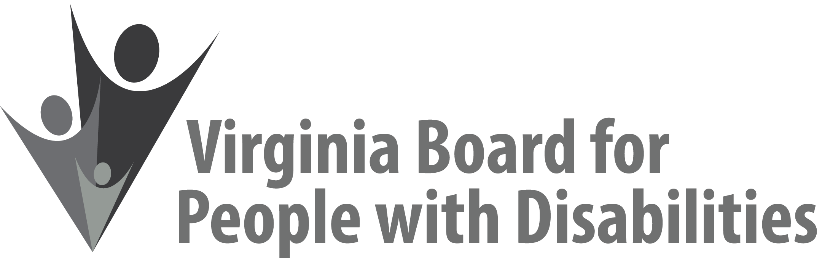

**Mission**To create a Commonwealth that advances opportunities for independence, personal decision-making and full participation in community life for individuals with developmental and other disabilities.

**Vision**Virginians with developmental and other disabilities direct their own lives and   
choose how they live, learn, work, and play.

**BOARD MEETING AGENDA**

**September 15, 2021**

**8:00am -8:45am Executive Committee (Attachment EC 1) *Shenandoah Junior Ballroom A***

**9:00 am COMMITTEE MEETINGS**

**Advocacy, Outreach, and Training *Shenandoah Junior Ballroom A***

**Investment Committee *Shenandoah Ballroom B***

**Policy Advisory Committee *Shenandoah Ballroom C***

**FULL BOARD CONVENES *Blue Ridge Ballroom***

**10:30** Welcome, Call to Order, Introduction of Board members, Alexus Smith

11:20 Public Comment

11:25 Approval of June 9, 2021 Board meeting minutes, **ACTION REQUIRED   
(Attachment BD 1),** Alexus Smith

11:30 Report of the Ad Hoc Committee: Board Packet, Meeting Agendas, and Board Member Engagement, **ACTION REQUIRED (BD 2**), Alexus Smith

12:15 **Lunch – *Blue Ridge Ballroom***

1:00 Intro to Cultural and Linguistic Competence, Teri Morgan

1:05 Cultural and Linguistic Competence, Dr. Vivian Jackson and Ms. Marisa Brown

**3:35 BREAK**

**3:45** Report of the Grant Review Team on Competitive Proposals, **ACTION REQUIRED, Supplemental Packet**

3:55 – 4:25 **Standing Committee Reports and Discussion**:

Report of the Investment Committee, Chandra Robinson

* Update on the Status of the Vaccine RFP **(IC 5)**, Jason Withers

Report of the Advocacy and Outreach Committee, Eric Mann

Report of the Policy Advisory Committee, Phil Caldwell

Questions on Executive Committee meeting, Alexus Smith

4:25 Board Policy 14.0: Electronic Participation and Meeting Policy, Teri Morgan, **ACTION REQUIRED (BD 3)**

4:35 Informational update of the Board's FFYs 2022-2026 State Plan and FFYs 2022-23 Work Plans, **(BD 4)**, Nia Harrison

4:45 Board Adjourns